Cooking Temperatures

165°F  (for 15 seconds) | 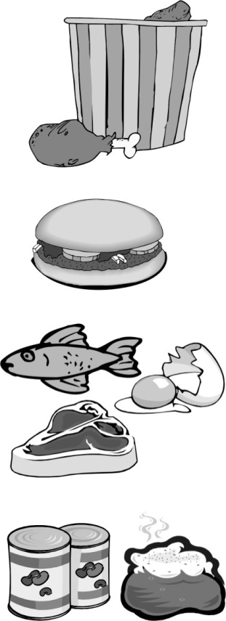 | - Poultry (chicken and turkey)  - Stuffed foods or stuffing  - Casseroles  - All raw animal products cooked in a microwave  - All reheated potentially hazardous foods
155°F  (for 15 seconds) |  | - Hamburger  - Sausage
145°F  (for 15 seconds) |  | - Eggs  - Fish  - Beef  - Pork
135°F |  | - Vegetables that will be hot held  - Packaged ready-to-eat foods (such as hot dogs and canned chili) that are heated for hot holding

Note: Beef or pork roasts have additional cooking requirements.
Please see the Washington State Food Rule or contact your local health department for more information.
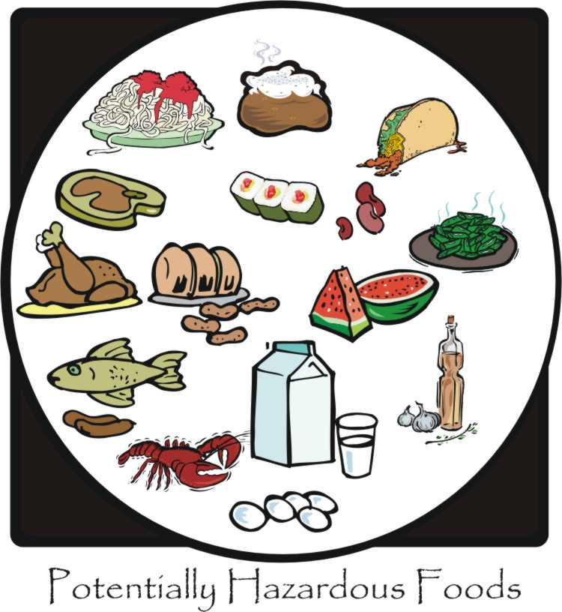
Potentially Hazardous Foods include:

Animal Products
- Meat, fish, poultry, seafood, eggs.
- Dairy products.
Cooked Starches
- Cooked rice, beans, pasta, potatoes.
Fruits and Vegetables
- Cooked vegetables.
- Tofu.
- Sprouts (such as alfalfa or bean sprouts).
- Cut melons, cut tomatoes, and
- Cut leafy greens.
- Garlic or herbs bottled in oil.

Cold Holding Hot Holding
