Lewis County Public Health &

Social Services

2012 Annual Report

Introduction
Table of Contents

Community Services 2
Administrative Services 4

Veterans Relief Fund 4

Social Services 5

Environmental Services 7

WIC 8

Animal Shelter 9

Financial Report 9

Message from the 10
County Department Director & Health Officer

Lewis County Public Health & Social Services is located in Southwest Washington in the County seat of Chehalis and serves a population of 75,901 citizens. The county was founded on December 19, 1845 and is named after Meriwether Lewis. The total area of Lewis County is 2,436 square miles. The Department is comprised of five divisions as listed below along with their programs:

Community Services: Women, Infants, and Children (WIC), Immunizations, Maternal and Child Health, Emergency Preparedness, Communicable Disease Response, Chronic Disease Prevention, Assessment, Senior Services

Environmental Services: Food Safety, Water Quality, On-Site Sewage, Solid Waste, Code Compliance, Water Lab
Administrative Services: Vital Records, Customer Service, Notary Public, Personnel, Board of Health, Department Contracts, Veterans Relief Fund
Social Services: Housing, Substance Abuse Prevention, Community Mobilization, Mental Health, Developmental Disabilities, DUI Traffic Safety
Animal Shelter: Animal Intake, Animal Adoptions, Reuniting Lost Animals with Owners.

Values

Our department fosters and endorses an environment of respect in all areas of our daily activities along with a non-judgmental outlook toward the people we serve and those with whom we work.

Integrity guides each employee to uphold professional ethics and serve with honesty, fairness, loyalty, and trustworthiness.

As stewards of the community, we hold ourselves accountable for our behavior, performance, and all resources entrusted to our department.

We are committed to using the least intrusive method possible to achieve optimal public health – informing and educating wherever possible, directing and regulating only when necessary.

Recognizing individual strengths, we encourage teamwork through active collaboration to solve problems, make decisions, and achieve common goals.
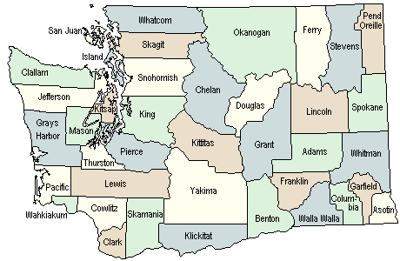

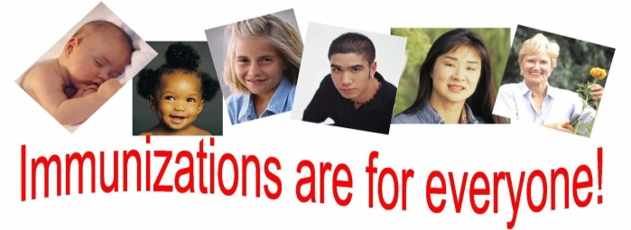

Community Services

Immunizations:

The immunizations program provides both childhood and adult vaccinations. In addition to administering vaccinations at the Health Department, our Immunization Nurse coordinates four childhood immunization programs. The following programs are designed to increase the county’s childhood vaccination rates and/or provide continuous quality improvement and outcome measurements:

1. Immunization AFIX (Assessment, Feedback, Incentive, & eXchange) – assesses clinic immunization rates and evaluates clinic systems looking for ways to improve their vaccination rates.
2. Immunization FA 317 (General Immunization Fund) – performs case management for Perinatal Hepatitis B babies and promotes vaccine awareness.
3. Immunization VFC (Vaccine for Children) – works with 21 clinics that provide childhood vaccinations in the County to ensure providers are storing and handling vaccines properly, documenting administration correctly, and giving them as recommended.
4. “Blue Ribbon” Vaccine - promotes increasing the uptake of under-utilized vaccines, specifically Influenza, Rotavirus, HPV, and Varicella. Other activities include working with providers, reminding parents to complete their child’s vaccine series, and promoting all recommended vaccines.

Encounters for Childhood Vaccinations | 480
Total number of vaccine doses given to children 0-18 years | 976
Encounters for Adult Vaccinations - including TB Skin Tests | 1640
Total number of vaccine doses given to adults  (not including Flu) | 810
Total number of Flu vaccines given to adults | 338
Two-year old children who have received required Childhood immunizations | 71%
Kindergarten children who have received required immunizations | 87.2%
Children in 6th Grade who have received required immunizations | 72.7%

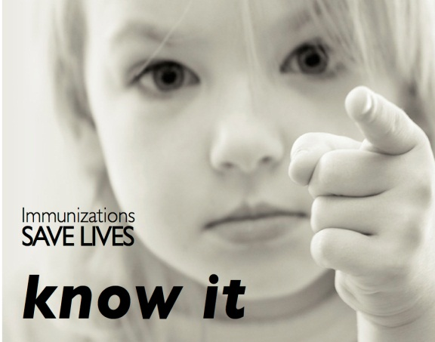

Tuberculosis (TB) Control:

Employees in the Community Services Division have the responsibility to control the spread of TB. TB is a disease caused by bacteria called Mycobacterium tuberculosis. It is contagious when it is in the lungs.

Definitions:
Latent TB or TB Infection: TB bacteria have entered the body but the body’s immune system is able to prevent the germs from growing, therefore the person remains healthy. The infection needs to be medically treated but is not contagious at this stage.
TB Disease: Disease occurs when the bacteria activate and become stronger than the body’s immune system. Then they start to grow within the body. TB disease can be contagious. It is treatable and can usually be cured if the person is diagnosed and receives medical treatment right away.

In 2012 we did not have any active cases of TB disease in Lewis County. We were able to rule out 9 cases through the use of lab tests, provided consultation and referrals on 12 possible cases, and evaluated and referred one case for further care.

Communicable Diseases:
Disease Investigations - 2012
Condition | Cases
Sexually transmitted diseases | 284
Hepatitis | 117
Possible rabies exposure | 81
Enteric diseases | 39
Other | 2

Public health investigates reported cases of
communicable disease in order to prevent the spread of disease in the community. LCPH&SS investigated 596 cases of communicable disease in 2012. Almost half of these were cases of sexually transmitted diseases. Hepatitis cases made up 20% of the caseload. The vast majority of these cases were chronic Hepatitis C. Possible rabies exposures accounted for about 14% of cases and were primarily due to interactions with bats and dogs. A pertussis epidemic led to the investigation of 73 pertussis cases which is about 10 times higher than average.

Enteric diseases which are primarily spread by eating or drinking contaminated food or water, made up 7% of all cases.

Chronic Disease Prevention

LCPHSS promotes community awareness of the importance of healthy behaviors to prevent chronic illnesses such as heart disease, cancer, stroke, and diabetes. We develop outreach materials and provide presentations focusing on healthy eating, physical activity and tobacco-free living. Opportunities for health begin in our homes, schools, workplaces, neighborhoods and communities, and we are striving to ensure that everyone has the opportunity to make healthy choices.

Maternal and Child Health

LCPHSS provides an array of services to promote and protect the health of women and children. Case management services are available for pregnant women and infants who have a high risk of poor health outcomes. We also work to ensure that all medically fragile children are connected to the resources that they need to maintain health. Additionally we are working to coordinate community services to support pregnant and parenting teens to complete high school. Together, all of these programs ensure that infants get the healthiest start possible. By providing extra help to families with health or social risks, LCPHSS helps children develop to their full potential and prevents them from developing long-term health issues, disabilities, and social problems.

Senior Services

Lewis County resumed operation of the senior centers in July 2012 making it one of the few, if not the only, county in the state to provide this service. The centers are located in Chehalis, Morton, Packwood, Toledo, and Winlock and provide a venue for seniors in our county to gather, socialize, enjoy lunch, pursue hobbies, and have a good time.

Administrative Services
The Administrative Services Division staff handles a variety of duties including: vital records, billings, accounts receivables, archiving, interpreter and translator services, immunizations intake and inventory, Notary Public services, recruiting/new hire documentation, personnel needs/records, supply/inventory, purchasing, budget tracking, scheduling and tracking employee training, processing contracts/resolutions, coordinating Public Disclosure Requests (PDR), and serving as the Board of Health Clerk. Program information and data for specific areas in the division are noted, although much of the work performed in this division cannot be captured with statistics.

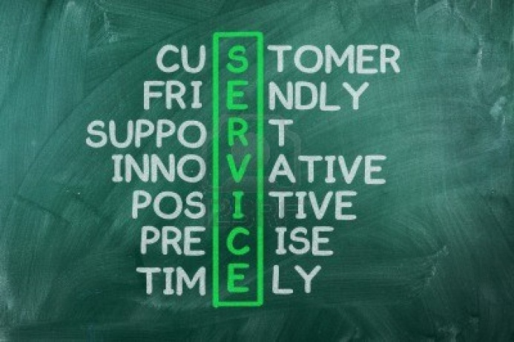
Vital Records
Births during 2011 (2012 not yet available) | 877
Deaths during 2012 | 822
Birth Certificates Issued in 2012 | 1827
Death Certificates Issued in 2012 | 2582

 | Resolutions | Agreements
Processed by BOCC | 36 | 43
Processed by BOH | 9 | 7
Processed by Director | N/A | 35
Total processed | 45 | 85

Resolutions/Agreements Processed

Veterans Relief Fund

Veterans Receiving Funds for Living Expenses | 302
Veterans Receiving Funds for Funeral Benefits | 23

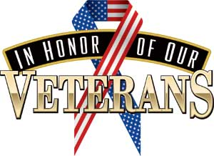

Fuel | $ 11,123.79
Rent | $ 23,819.11
Food | $ 48,667.61
Utilities | $ 37,148.18
Miscellaneous (medical, mini grant) | $ 10,209.30
Funeral | $ 10,350.00
Total | $141,317.99
Total amount spent in each category:

Driving Under the Influence (DUI) Traffic Safety:

Emphasis Patrols for 2012

DUI:
72 | Scheduled DUI emphasis patrols
190 | DUI/other alcohol related arrests
26 | Driving With License Suspended (DWLS)
5 | Speeding infractions
5 | No insurance
6 | Drug arrests
3 | Seat belt infractions
0 | Car seat infractions

Speed:
1332 | Speed infractions
37 | DWLS
4 | Seat belt infractions
0 | Car seat infractions

Nighttime Seatbelt (NTSB):
33 | Scheduled NTSB emphasis patrols
74 | Seat belt infractions
1 | DWLS
1 | Speeding infractions
70 | Cell phone usage infraction
1178 | No insurance infractions
19 | Car seat infractions

Target Zero’s goal is to end traffic deaths and serious injuries by 2030. Programs include: Safety City, Texting and Driving Education, Drinking and Driving Education, Seat Belt Education, and DUI Victims Impact Panel.
Social Services

The Social Services Division embodies the mission of LCPHSS by coordinating services that are in place to promote, enhance, and protect the well-being of the community. Social Services programs are targeted for the indigent, low-income and underserved populations. We coordinate state & federal grants for services delivered by community providers, including: Chemical Dependency Treatment and Prevention, Developmental Disabilities Adult Employment Programs, High School Transition to Employment for students with developmental disabilities, Child Development, Homeless and Housing Assistance, and DUI/Traffic Safety Education. A Mental Health Liaison helps address the gaps in services and increases collaboration between community partners who deliver services to individuals with Mental Illness.

Developmental Disabilities:

2012 Notable Accomplishments
- The Autism Coalition hosted the 2nd Annual Lewis County Autism Conference. Attendance doubled from the previous year.
- New funding from the ARC of Washington was received to expand
High School Transition Services from school to employment.
- Special Olympics saw an increase in athlete participation and was able to expand the sports program.

Individual Supported Employment
Total Served: 46
Total Wages Earned: $102,675.96
Total Hours Worked: 28,883
Support Dollars Spent: $232,890.38

Group Supported Employment
Total Served: 56
Total Wages Earned: $205,557.72
Total Hours Worked: 21,218
Support Dollars Spent: $285,449.50

Chemical Dependency Treatment:
Morton RX Drop Box – 29 pounds
Centralia PD RX Drop Box – 772 pounds
Packwood and Chehalis RX Drop Boxes – 330.28 pounds

Lewis County has four publicly funded treatment providers: Community Allied Behavioral Health, Eugenia Center, Fresh Start and True North Student Assistance Program. There were 378 adults admitted to treatment in 2012 with a 34.2% treatment completion rate. Of those adults completing treatment in 2012, they spent an average of 410 days in treatment. Of those who did not complete treatment, they spent a median of 186 days. The primary drug of addiction that adults were treated for is Alcohol. The close second was Methamphetamine followed by Marijuana.
During that same period, there were 148 youth admitted to treatment with 21.6% completing treatment. The primary drug of addiction for youth in treatment was Marijuana followed by Alcohol.
The average cost for a treatment episode for adults is $1,790 per year per individual.

RX Drop Boxes:
Citizens may bring prescriptions to drop boxes throughout the county for safe disposal. Lewis County collected over 1,131 pounds.

Prevention:
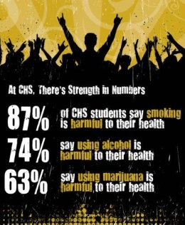

- LCPHSS in partnership with TOGETHER! brought the Positive Social Norms Campaign to Centralia High School. Ellen Termine, vice principal at Centralia, heard about the two-year project at last year’s Meth and More Conference.

- The goals of the campaign is to correct the student’s misperceptions about substance abuse, increase student perception of harms from substance use, increase student perception of peer and parental disapproval of substance use and decrease student alcohol, tobacco, and other substance abuse and related harms.

- 816 students in 9th - 12th grade took an anonymous survey. 147 surveys were thrown due to obvious false information provided. From the remaining analyzed data, a series of 9 posters were created for each month of the school year. The leadership students were given talking points to discuss with their peers and they are also responsible to change the posters each month.

Mental Health:
- Mental Health First Aid Training – Trained 109 people including staff from Lewis County Juvenile Court, Providence Centralia Hospital, Possibilities Pregnancy Center, and Chehalis West Assisted Living.

- Mental Health Coalition meetings – Guest speakers included representatives from Cascade Mental Health Care, Timberlands Regional Support Network, HarborCrest Medical Detox in Aberdeen, Reliable Enterprises, Magnolia Housing Program, and Veterans Administration Veteran Suicide Program.

- Hosted Seeking Safety trauma-informed group treatment training for local chemical dependency professionals.

Housing:
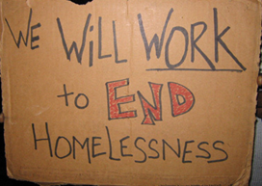
- In 2012, 3,993 people in 1,766 households were served with homeless and housing funds. Lewis County Public Health & Social Services Housing programs also co-hosted several trainings and informational workshops to educate and raise awareness of the issues.

- On the one-night “Point in Time Homeless Count”, which is held every January, 328 individuals were counted as homeless. Over 100 people attended the Project Homeless Connect event to access various services and received a hot meal.

      - 218 students were registered as homeless in our County’s largest school district. These students were offered transportation, supplies, tutoring, after-school programs, and extra snacks for the week-end. Our Department sends a school representative to the National Homeless Children’s conference who brings back information and shares with all school district liaisons.

Environmental Services

Code Enforcement:
Hulk Vehicle Inspections | 430
Tons of illegal tires disposed | 127.54
County abatements (nuisance) | 0
County abatements (other-illegal dumping) | 12
Complaints by type:
Hulk Vehicles | 21
On-site sewage | 60
Solid waste | 143
Building | 163
Clean Indoor Act | 2
Planning | 15
Public Works | 0
Water Quality | 7
Dangerous animal | 6
Potentially dangerous animal | 32
Animal neglect | 18
Total Complaints Received | 456
Civil Infractions:
Issued | 9
Infractions issued for multiple individual violations:
Solid waste |  | 16
Hulk vehicle |  | 7
Littering |  | 9
Building |  | 5
On-site sewage violation |  | 5
Solid Waste:
Facilities designated as exempt sites |  | 9
Facilities with permits |  | 5
Site Hazard Initial Investigations |  | 4
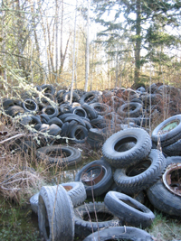

Water Program:
Water Approvals |  | 5
Well Sites |  | 12
Water Availability Review |  | 48
Nitrate Analysis |  | Na
Group A Assessments |  | 25
Group A Technical Assistance |  | 22
Reduce SCA: |  | 3
Coliform:
Non acute Group B resolved |  | 29
Pending |  | 5
Acute Pending |  | 0
Nitrates:
Group B Pending (Quarterly) |  | 4
Group B Pending (Monthly) |  | 2
Meth:
Meth labs closed | 9
On-Site Program:
Septic Permit Applications |  | 207
Operation & Maintenance Permits |  | 5
Soil Evaluations |  | 14
Permits Issued |  | 185
Combined EH Reviews:
State Environmental Policy Act (SEPA) |  | 22
Administrative Variance |  | 1
Administrative Approval |  | 1
Boundary Line Adjustment |  | 24
Large Lot Subdivision |  | 1
Short Plat |  | 3
Special Use Permit |  | 1

Food Safety Program:

Permits Issued
Annual Permanent Permits | 411
Seasonal Permits | 21
Temporary Permits | 397
Food Handler Cards
Classes held | 61
Cards issued from in-person classes | 450
Cards issued from online classes  (plus 39 Replacement cards) | 2380
Inspections
Temporary Establishment Inspections | 308
Permanent Establishments Inspected (not schools) | 320
40 Schools Inspected (2 times each)  (80 inspections total) | 80
Re-inspections | 20
Pre-Opening Inspections | 41
Total Permanent Establishment Inspections | 769

WIC - Women, Infant & Children

WIC is a preventive public health nutrition program that provides nutrition and breastfeeding education, nutritious foods, and improved access to regular health care and social services to low and moderate income women and young children with, or at risk of developing, nutrition related health problems. WIC helps families get the services they need.
4,583 clients - Women, Infants and Children served in Lewis County in 2012.

WIC attracts families to preventive health services:

WIC Referrals: 15,213
WIC and the Farmers Market Nutrition Programs Benefit the Local Economy:

- Dollars to grocery stores $1,883,567
- Dollars to farmers $ 5,185

64% of WIC families are working families and 71% of WIC families are living in poverty (even though they are working, the majority of WIC families are living in poverty).

WIC Nutrition Education Promotes Healthy Choices: Total nutrition education sessions: 12,268

WIC Nutrition education:
- Emphasizes healthy habits so families can eat better and stay active to prevent obesity and
chronic diseases
- Promotes breastfeeding for at
least the first year of life
- Helps working mothers breast-
feed longer by providing breast pumps
- Helps prevent early childhood caries by giving parents ideas for healthy snacks and stressing dental care by age one

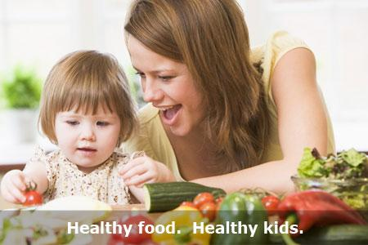

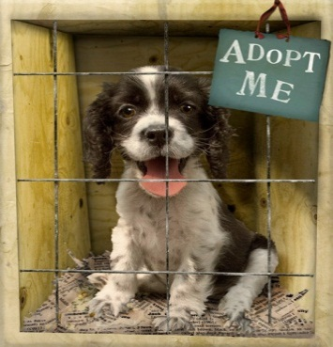
Animal Shelter

The animal shelter receives some fees for services but is mainly sustained by County general funds (Current Expense) and donations.

Donations may be sent directly to the Animal Shelter at:

Lewis County Animal Shelter
P. O. Box 367 Chehalis WA 98532

You can visit the shelter and find your perfect family pet at:

560 Centralia Alpha Road, Centralia

The shelter is always looking for individuals who would like to volunteer to help at the shelter. If you or a family member is interested in volunteering, contact the shelter at
(360) 740-1290. (Volunteers must be 12 years old and all volunteers must complete a one-hour training class.)

2012 Statistics

Animals Received (dogs and cats) | 1676
Animals Adopted | 1066
Animals returned | 169
Animals destroyed | 389
Percent destroyed | 23%
Volunteers (new attending orientation) | 72

Financial Report

A Message from the County Department Director and Health Officer

Lewis County
Board of Health

Commissioner Edna J. Fund
Commissioner Bill Schulte
Commissioner F. Lee Grose

Lewis County Board of Health Advisory Committee

Ron Pollock
Cherie Rusk
Dr. Richard Price
Neal Kirby
Don Haviland Sr.
Matt Patten
Julie Schaffley
Mary DeMun, RN
Danette York
Dr. Rachel Wood

Lewis County Public Health
& Social Services

360 NW North Street
Chehalis, WA 98532

360-740-1223 Phone
360-740-1472 Fax

www.lewiscountywa.gov
LCPHSS is part of a state-wide public health network that works to improve the health of our communities and the environment. In 2011, the public health “Agenda for Change” was drafted as a strategic plan for responding to a rapidly changing environment. This environment includes emerging and re-emerging diseases, reforming healthcare, and dealing with diminishing healthcare resources. Our department has adopted the goal of the Agenda for Change, which is to help every Washington State resident have a better chance for a healthy, safe and economically productive life.
The Agenda for Change was finalized in 2012. It details priorities in planning for a healthier future as: 1) preventing communicable disease and other health threats, 2) fostering healthy communities and environments, 3) partnering with the healthcare system, and 4) providing a minimum package of public health services. LCPHSS can better achieve these priorities by working with our partners.
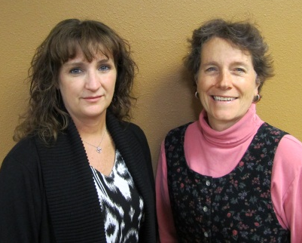
LCPHSS works with many partners in improving the health of our citizens. Just a few examples of our partners and their ability to effect health improvement include: Childcare Centers and Schools (adopt healthy food and drink guidelines), Community Businesses (adopt wellness policies and provide physical activity choices for employees), Community Organizations (participate in coalitions to develop policies that improve health), the Healthcare System (improve immunization rates and access to care), housing authorities and organizations (educate residents about the risks of second-hand smoke and the benefits of quitting, develop smoke free policies for public housing) and many more. LCPHSS appreciates the opportunity to work side by side with every individual, healthcare agency, both public and private organizations, and local businesses to improve the health of Lewis County citizens.
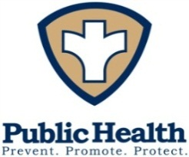
Danette York Dr. Rachel Wood Director Health Officer
Mission: Lewis County Public Health & Social Services strives to promote, enhance, and protect the health and well-being of our community through partnerships, education, and prevention services.

Vision: Healthy people, strong families, and vibrant communities… a healthy Lewis County.

