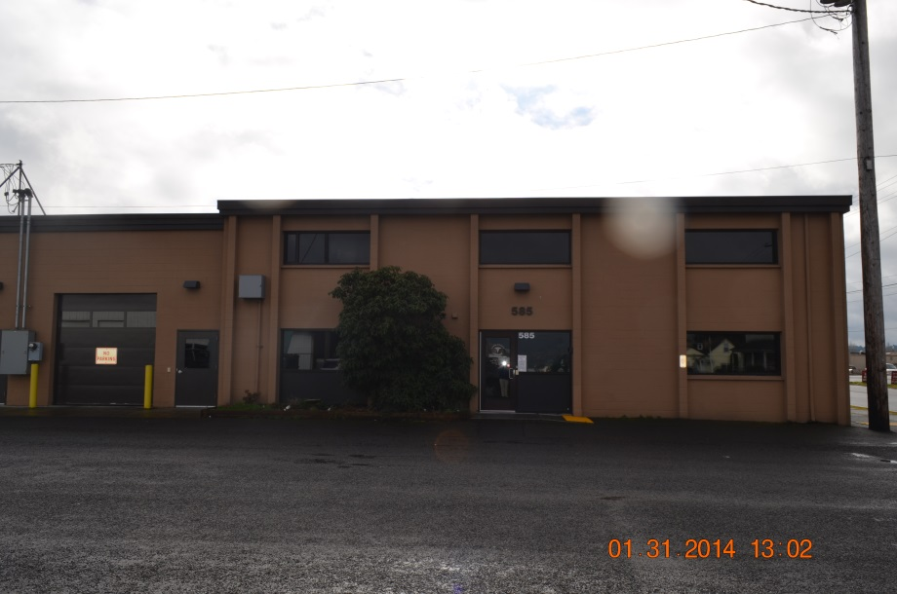

Lewis County Coroner’s Office
585 NW Center St. Chehalis, WA 98532 360-740-1376 | 2015 Annual Report

It is important to remember that every statistic in this report represents a person who is missed by family and friends and is also a loss to our community

Warren McLeod, MA, D-ABMDI Lewis County Coroner

TABLE OF CONTENTS

Mission and Vision Statements...................................................................................................1

Forward………………………...............................................................................................................2-3

Description and purpose............................................................................................................3-7

Annual statistics……………….……………………………………………………………………………………………………..8

1
MISSION STATEMENT
The Lewis County Coroner’s Office determines the cause and manner of reported deaths by conducting professional medicolegal death investigations while ensuring that everyone who has suffered a loss is treated with dignity, respect and compassion. The Lewis County Coroner’s Office is dedicated to improving the professional development of all staff through continued training while working collaboratively with the community to identify and proactively respond to issues and concerns related to death investigations.

VISION STATEMENT
1. The LCCO is accessible and accountable to the public, media and other elected officials. 2. The LCCO continually strives to increase the proficiency and professionalism of all staff members through training. 3. The LCCO endeavors to develop and strengthen partnerships with the public safety community. 4. The LCCO works with community partners to adopt a proactive approach to reducing preventable deaths.

2
FORWARD
The Lewis County Coroner’s Office (LCCO) serves the county by investigating sudden, unexpected, violent, suspicious and unnatural deaths. All members of the LCCO staff recognize that every death investigated involves grieving family members as well as friends and co-workers. Conducting timely and complete death investigations is necessary, in part, to assist those grieving people. Complete investigations also help families with the settling of issues such as estate and insurance claims as well as any criminal or civil actions. Often times questions come up long after the death that were not thought of at the time and complete and thorough investigations aid in the answering of these questions.
Deaths investigated by the LCCO include on-the-job deaths and these investigations are conducted in conjunction with the Washington State Department of Labor and Industries (L & I).
The LCCO also plays a role in the area of public health by isolating and identifying the causes of sudden, unexpected deaths that might affect groups of people. If an infectious agent or toxin is implicated in a death the LCCO works with Lewis County Public Health to ensure family members and other contacts of the decedent receive any needed medical treatment.
In cases that are unexpected deaths at home, suspicious circumstances, homicide, suicide, drug-related or traffic deaths the LCCO works closely with the jurisdictional law enforcement agency. The agencies conduct parallel investigations while cooperating fully with each other. All members of the LCCO staff are subject to being subpoenaed to testify in civil/criminal cases as to the extent of the investigation they conducted.
In summary the LCCO provides expert medicolegal death investigations and services related to deaths that are of concern to the health, safety and welfare of Lewis County.

3
Lewis County is approximately 2, 402. 80 square miles and has a population of approximately 7,061,530.
DESCRIPTION AND PURPOSE
The LCCO is funded by Lewis County and operates under the direction of the Coroner. The Coroner is a full-time elected position and is responsible for the administration of the office, the budget, accounts payable, the staff and for determining the cause and manner of deaths reported. The Coroner also responds to calls in the field.
The Chief Deputy Coroner is a full-time position and serves at the will of the Coroner. The Chief Deputy Coroner is responsible for payroll, staffing and is often times the first line of contact with families. The Chief Deputy Coroner also responds to calls in the field.
The staff is comprised of Deputy Coroners who are classified as “extra help” by the county. The Deputy Coroners work on-call from home and respond to the locations where deaths have occurred in order to conduct medicolegal death investigations. These investigations involve:
- obtaining preliminary information from law enforcement
- getting detailed information from families and witnesses
- locating and documenting physical evidence
- documenting the scene and decedent with photographs
- performing a comprehensive external physical examination of the decedent
- inventorying the prescription medications
- inventorying the property
- arranging for transport of the decedent
- getting the decedent identified
- locating and notifying the next of kin
- obtaining medical records

4
- writing a comprehensive investigative report
- drawing toxicological specimens
- assisting during autopsies
- testifying in court as needed
Deaths that fall under the jurisdiction of the Lewis County Coroner’s Office are defined by state statute (RCW 68.50.010) and include but are not limited to:
- deaths of persons who were in apparent good health without medical attendance within the thirty-six hours preceding death
- deaths caused by unnatural or unlawful means
- death occurs under suspicious circumstances
- where a coroner's autopsy or coroner's inquest is to be held
- death results from unknown or obscure causes
- death occurs within one year following an accident
- death is caused by any violence whatsoever
- death results from a known or suspected abortion; whether self-induced or otherwise
- death results from drowning, hanging, burns, electrocution, gunshot wounds, stabs or cuts, lightning, starvation, radiation, exposure, alcoholism, narcotics or other addictions, tetanus, strangulations, suffocation or smothering
- death is due to premature birth or still birth
- death is due to a violent contagious disease or suspected contagious disease which may be a public health hazard;
- death results from alleged rape, carnal knowledge or sodomy
- death occurs in a jail or prison
- when a decedent is found dead or is not claimed by relatives or friends
Not all cases reported to the LCCO fall within our jurisdiction. There are decedents who are on hospice and their death is expected due to a terminal illness.
The LCCO also has a pre-registration program whereby a physician can place their patient on a list indicating the patient is suffering from a diagnosed medical
5
condition, the family’s mortuary preference and attesting that the physician will sign the Death Certificate. When the decedent passes away the family calls the
mortuary directly and the decedent goes to the mortuary. This allows people to die at home with dignity and peace of mind for the families.
The Coroner is responsible for determining the cause and manner of all reported deaths. A cause of death is what directly led to the person’s death. The causes of death are numerous and can include:
-heart attack -stroke -gunshot wound -drowning -cancer -overdose -pneumonia
The manner of death is a category that the cause of death falls under and there are only five manners:
Natural: Deaths from the natural disease process.
Homicide: The killing of one human being by another.
Suicide: The intentional taking of one owns life or a death that results from engaging in a behavior that a reasonable person would know could result in death.
Accidental: There is no intent on the part of the decedent to end their life.
Undetermined: When the manner of death is not able to be forensically ascertained.
Cases that do fall under the jurisdiction of the LCCO will have a scene investigation completed and the decedent can be released to the mortuary of the family’s choice or will be transported to LCCO if the family has no mortuary choice at the time of death in cases of natural deaths.

6
There are times the decedent has to be transported to the LCCO because their death requires an examination by a Forensic Pathologist. The LCCO has a contract with two (2) Board Certified Forensic Pathologists who come to the facility to perform these exams as needed. The exams can either be:
1. External exam: A comprehensive head-to-toe external exam where the pathologist is looking for signs of specific types of diseases or injuries.
2. Autopsy: A comprehensive head-to-toe external examination as well as a complete internal examination. Contrary to popular belief decedents who have an autopsy performed can still be viewed by family and friends afterwards at the funeral home.
Not every death that occurs or comes into the office is autopsied. The only cases that are automatically autopsied are homicides, violent deaths, suicides, traffic collisions. Many times the decedent will be brought to the LCCO for a physical examination. The only times this office is allowed to perform an autopsy is outlined by state statute and covers the types of deaths listed above. In cases of natural deaths we have no jurisdiction to perform an autopsy since it was not a violent or unexpected death.
The LCCO is also involved in toxicological testing. This involves drawing various biological samples for testing to see what level of any substance might be in the decedent’s system. This testing is done by the Washington State Patrol Crime Laboratory at no charge to the county. What is frustrating in these cases is that unlike television, the toxicological results take anywhere between six (6) to eight (8) weeks to come back. This turnaround time is pretty much the standard time nationwide.
The LCCO has other responsibilities as well:
1. Ensure that all decedents are positively identified and this is done by:
a. Viewing the decedent
b. Viewing driver license photos or post mortem photos
c. Fingerprints
d. Dental exams

7
e. DNA. Again unlike television, this does not have a quick turnaround. We rely on the University of North Texas to perform the DNA exams at no charge and these can take well over one year, sometimes longer, to complete.
2. Locate and notify the next of kin for the decedent. Per the RCW the progression for next of kin is as follows:
The designated agent of the decedent as directed through a written document signed and dated by the decedent in the presence of a witness. The direction of the designated agent is sufficient to direct the type, place, and method of disposition;
The surviving spouse or state registered domestic partner;
The majority of the surviving adult children of the decedent;
The surviving parents of the decedent;
The majority of the surviving siblings of the decedent;
A court-appointed guardian for the person at the time of the person's death.
Locating and notifying the next of kin is often times very easy to do as family members are present or nearby when a person passes away. There are other cases where the family is not so easy to find. We use a variety of search engines available to law enforcement to try and locate families. In cases where families cannot be located within ninety (90) days the decedent is cremated at the county expense and the cremated remains are held at the LCCO until family members might be found.
Since 2012 the LCCO has been interning unclaimed cremated remains in local cemeteries. When the internment is scheduled we announce it to the public so people can attend to pay last respects to folks who have been forgotten.
In the case of unclaimed veteran’s cremated remains we are part of a program called “Operation At Ease’ whereby the remains are released to local veterans groups for burial at the Tahoma National Cemetery in Kent, WA with military honors.

8
STATISTICS
The statistics provided below are generic and will not list details in the types of cases. This is done purposefully to preserve the dignity and confidentiality for the surviving family members and friends.
Total number of deaths in Lewis County in 2011: 769
NATURAL | HOMICIDE | SUICIDE | ACCIDENTAL | UNDETERMINED | OUT OF COUNTY ASSISTS | AUTOPSIES
722 | 4 | 9 | 29 | 3 | 2 | 40

Total number of deaths in Lewis County in 2012: 822
NATURAL | HOMICIDE | SUICIDE | ACCIDENTAL | UNDETERMINED | OUT OF COUNTY ASSISTS | AUTOPSIES
783 | 4 | 14 | 19 | 2 | 0 | 65

Total number of deaths in Lewis County in 2013: 714
NATURAL | HOMICIDE | SUICIDE | ACCIDENTAL | UNDETERMINED | OUT OF COUNTY ASSISTS | AUTOPSIES
670 | 1 | 16 | 18 | 4 | 5 | 41

Total number of deaths in Lewis County in 2014: 716
NATURAL | HOMICIDE | SUICIDE | ACCIDENTAL | UNDETERMINED | OUT OF COUNTY ASSISTS | AUTOPSIES
656 | 4 | 21 | 30 | 5 | 0 | 74

8

Total number of deaths in Lewis County in 2015: 767
NATURAL | HOMICIDE | SUICIDE | ACCIDENTAL | UNDETERMINED | OUT OF COUNTY ASSISTS | AUTOPSIES
710 | 0 | 11 | 33 | 13 | 0 | 62

2014 estimate. Source: http://quickfacts.census.gov/qfd/states/53/53041.html

