Department of Emergency Services (DES)

Annual Report - 2018

911 Communications Center Division

&

Radio Services Division

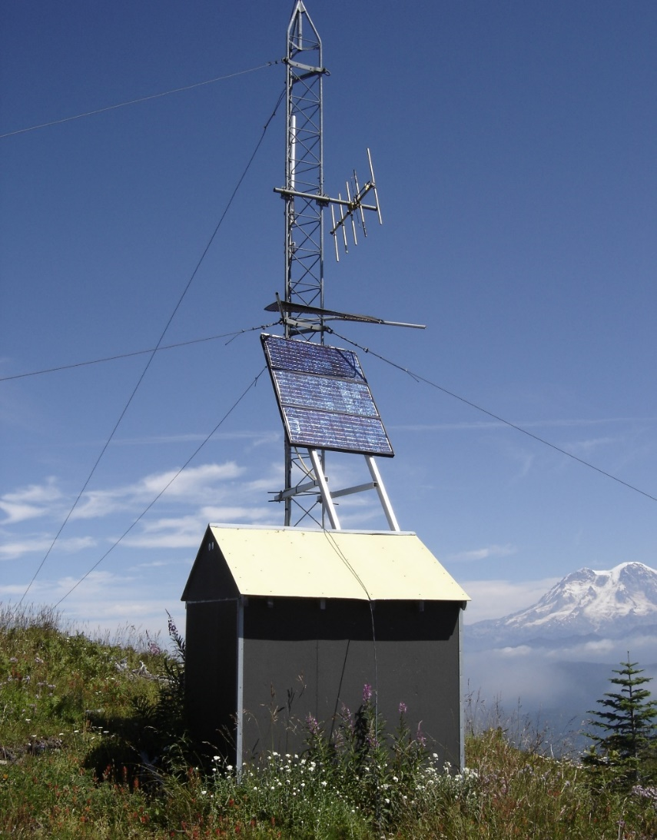

*Twenty-five foot Storm King Communications Tower located at, Mineral, WA.*

*It houses Fire and Law repeaters powered by solar panels, with back-up batteries.*

Prepared by

Steve Mansfield, Director

Department of Emergency Services (DES)

I. Introduction

**Director’s Message**

As the Director of Emergency Services, it is my honor to present this 2018 Annual Report. I saw 2017 as a year of stabilization and identification of major challenges in terms of personnel, finance, services and reestablishing credibility. In 2018, to help meet the challenges we are facing, we saw a year of implementing change at all levels in the organization. Some of the changes included a new Interlocal Agreement (ILA), a quality assurance/quality control program and the implementation of Next Generation 911 (providing the ability for 911 to receive text messages).

This report represents and reflects progressive change and highlights of what we have accomplished. It also provides a brief glimpse into our purpose, commitment, governance, budget and services provided. We continue to address challenges in new, creative and innovative ways.

We are meeting our Public Safety Mission and our quality of service is promoting trust, confidence and a feeling of safety and security. We are being creative and innovative in finding more effective, efficient and safe ways to conduct business. We are hiring and retaining competent individuals. The management staff is providing timely and consistent training so our employees can excel at their essential job functions. We are implementing comprehensive policies, developing procedures to guide us and insuring engaging supervision. We are promoting the use of best practices to encourage making decisions the right way and for the right reasons.

Our activities reflect the details of this positive change, outstanding work and commitment by the Department of Emergency Services staff. This report should also give the reader a sense of our strengths and future challenges. It illustrates how far we have come and provides a roadmap into the many options that lay ahead as we take on the next set of challenges.

We continue to strive for perfection every day. We are making a positive difference and achieving success in meeting our mission. It is my expectation the positive changes that have affected our performance in 2018 will continue into the future.

Steve Mansfield**, DES Director**

**History**

Lewis County 911 Communications has provided call taking and dispatching services to the citizens and first responders of Lewis County since the mid-1980s. During that time, there has been evolutionary changes in the level of service, organization structure and governance of the program.

In 2016, the Board of County Directors (BOCC) committed to embark upon a journey of change for our Lewis County 911 Communications Center. The challenges moving forward were multi-faceted as the relationships between public safety disciplines and the 911 Communications Center had become contentious. There were also challenges with ever-changing technology, levels of acceptable service and division of costs to maintain a single Public Safety Answering Point (PSAP).

The first responder community had serious concerns about how to provide input into the process and how to continue to pay for the escalating costs/fees. These challenges pushed a new community awareness and public debate on the operation of the PSAP. All the partners were forced to commit to a process of reevaluating not only what needed to be done, but also how we go about conducting and financing the operation.

On March 1, 2017, in an effort to move forward and provide stakeholders with the best service possible, the BOCC created the Department of Emergency Services (DES) and appointed Steve Mansfield as the Director.

DES includes the divisions of the 911 Communications Center, Radio Services and the Division of Emergency Management (DEM). (The DEM annual report is published as a separate report.)

The Lewis County 911 Communications Center is the primary answering point for all 911 calls placed in Lewis County. The Radio Services Division provides technical/maintenance support for the Communications Center and maintains/develops the radio communications infrastructure equipment at 22 sites throughout the County. This network consists of separate but interconnected equipment allowing the first responder community to talk to each other and the Communications Center.

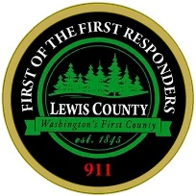

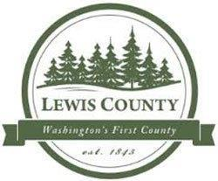

II. Overview of 2018 Major Accomplishments

**911 Communications Center – Staffing, Training & Programs**

* Increased 911 TCOs from 12 at the beginning of 2018 to 19 at the end of 2018.
* The 2018 overtime budget was reduced 36% (from $222,775 in 2017 to $142,264 in 2018) by direct oversight and best practices.
* Shorten training time from 12 months to approximately 7 months, netting a budget savings of approximately $52,000 per successful trainee.
* There were 222,394 telephone and radio calls for service received at the 911 Communications Center. Of that total, 34% (76,612) created a dispatch service. There were no public inquiries (grievances) received and only 49 (.06%) from the response groups. (Note: On review, 14 of these were categorized as “Unfounded” or “Not Sustained”.)
* Implemented “Open Application” process to develop a perpetual applicant list to shorten recruitment time.
* Increased TCO training verifications (required on-going training) from 35% to 90%.
* Initiated supervisor training program.
* Initiated Quality Assessment & Improvement program. All TCOs exceeded National Emergency Number Association (NENA) standards for answering 911 calls.
* Initiated recognition program with seven (7) categories and eight (8) non-monetary awards.
* County Outreach programs included Safety City, Southwest Washington Fair participation, and operating a Facebook page.

**Interlocal Agreement & Combined User Committee**

* **Combined User Committee (CUC)**

Reorganized the 911 Communications Center partner agencies (32) into a Combined User Committee (CUC) and ratified a two-year Interlocal Agreement (ILA):

* **ILA Developed & Adopted**

Worked with Fire and Law representatives to develop the ILA that was completed and sent to partner agencies on January 26, 2018. This agreement was fully executed by the 32 entities on July 11, 2018. This included naming one (1) voting member from each agency.

* 1. Elected a Chair and Vice Chair March 30, 2018.
  2. In 2018, CUC business meetings were held on March 30, July 30 and October11. Additionally, several Budget Subcommittee work sessions were conducted.
  3. Approved Fire and Law fees for 2019.
* **Communications Strategic Plan**

A Strategic Plan was developed that included a work program and tentative timeline. During 2018, several new considerations resulted in several modifications to the original timeline. Some activities were postponed and will be completed in 2019; others are on hold until the “Regionalization” concept has been explored.

* Individual Fire Services District user rates were recalculated in 2018 (Law is scheduled to be recalculated in 2019).

**911 Communications Center – Policies & Administration Matters**

* **Public Records Requests (PDR)**

Public Records Requests (PDR) (525 hours to process 321 requests) consumed one-fourth of the administrative assistant FTE.

* **CALEA Policy Standards Adopted for 911 Center**

Reorganized the 911 Communications Center policies into the Commission on Accreditation for Law Enforcement Agencies (CALEA) policy format.

* **Dispatch Regionalization Consideration**. Some CUC representatives presented their interest in pursuing regionalization of dispatching service with TCOMM, a non-profit based Thurston County dispatching organization. Their proposal was brought to the Board of County Commissioners. Exploration of that option will continue into 2019.
  1. Several items listed in the Strategic Plan have been placed on hold due to the exploration of regionalization of dispatch services. Consideration of evaluating the current Communications facility is delayed until other decisions are made.

**Communications Infrastructure**

* **Communications Infrastructure Study**.

Established the scope of services to update the 2005 ADCOMM Communications Study.

* 1. Reviewed 2005 study, extracted only Law/Fire issues, wrote scope of services to update study results based on currently available technology, establish a cost estimate and included a build-out plan for development.
  2. Published a Request for Qualifications (RFQ) to hire a consultant. The RFQ was posted through the end of 2018 with selection and contract for services ratified in early 2019.
  3. Revised a Homeland Security grant to cover approximately $28,000 of the costs.

**Grants**

* **Grant Application – Fire Services Paging System**.

Submitted grant application to TransAlta for Phase I – West Side Fire Services Paging System (total project: $200,000 with 50% local match required).

This system will provide a separate channel for on-scene responder communications to increase responders’ safety. Phase II will expand that system with similar coverage for the East Lewis County area. The application was updated and resubmitted twice due to available funds being depleted. (Note: Another application was submitted that will be reviewed in January, 2020.)

**Lewis County Alert & Warning System**

* The Lewis County Alert (Warning and Notification system) includes 20,528 landline telephone numbers and 4,093 self-registrations.
  1. In 2018, there were 1,495 tests and notifications issued.
  2. In 2018, there were 6 alert messages sent to the community

**2018 Operation Budgets & Staff Levels**

|  |  |
| --- | --- |
| **2018 Communications Operation Budget** | |
| 911 Communications Center | $ 2,336,500 |
| Radio Services | 333,500 |
| **Total Combined Communications Budgets** | **$ 2,670,000** |

|  |  |  |  |  |
| --- | --- | --- | --- | --- |
| **Staff Positions** | | | | |
| **911 Center** | |  | **Radio Services** | |
| TCO | **16** |  | Administrator | **1** |
| Supervisor | **4** |  | Technician | **1** |
| Chief | **1** |  | Director | **.1** |
| Manager | **1** |  |  |  |
| Admin. Asst. | **1** |  |  |  |
| Director | **.6** |  |  |  |
| **Total FTEs** | **23.6** |  |  | **2.1** |

**Capital Improvements Costs (**funded by Lewis County only)

* **Capital Facilities Plan Consultant – Plans for new 911 Center**.

The Lewis County Board of County Commissioners have contracted with a consultant firm to develop plans for a new 911 Communications Center. (The final recommendations are expected in mid-2019.)

* **Infrastructure Development**

The following list of 2018 facility/site enhancement projects were funded by Lewis County alone:

1. Back-up Communications Center $ 25,864.67
2. Chehalis Ridge Radio Site Development 167,369.00
3. ADCOMM Infrastructure Study (allocated in 2018) 28,000.00
4. Communications Center Radio & Phone Upgrade 870,000.00

**Total 2018 Capital Improvement Costs** **$ 1,091,233.67**

III Table of Contents

**I. Introductions** **i - ii**

Director’s Message i

History i **-** ii

**II. Overview of 2018 Major Accomplishments** **iii - v**

911 Communications Center – Staffing, Training & Programs iii

Interlocal Agreement & Combined User Committee iii

Combined User Committee (CUC) iii

ILA Developed & Adopted iii

Communications Strategic Plan iv

911 Communications Center – Policies & Administration Matters iv

Public Records Requests (PDR) iv

CALEA Policy Standards Adopted for 911 Center iv

Dispatch Regionalization Consideration iv

Communications Infrastructure iv **-** v

Communications Infrastructure Study iv

Grants iv

Lewis County Alert & Warning System v

2018 Operation Budgets & Staff Levels v

Capital Improvements Costs (funded by Lewis County only) v

Capital Facilities Plan Consultant – Plans for new 911 Center v

Infrastructure Development v

**III. Table of Contents** **vi - vii**

**IV. Department of Emergency Services**   **1 - 3**

A. Department of Emergency Services (DES) 1

1. Mission & Purpose 1 **-** 2

2. Ethical Values 3

3. Performance Directed Management Program 3

4. Leadership Framework 3

B. Personnel 4

1. Radio Services Division 4

a. Staffing Levels 4

b. Training 4

2. 911 Communications Center Division 4 **-** 10

a. Staffing Levels 4 **-** 5

b. Collective Bargaining Agreement (CBA) 5

c. Hiring Process – Move to “Open Application” Process 5

d. Testing, Background Investigations and Hiring Procedures 5

e. Training 6 **-** 7

1) New Hire Training 6

2) On-going TCO Training – Target Solutions Program 6 **-** 7

3) Supervisor Training Program 7

f. Quality Assessment & Improvement Program 7 - 8

g. Performance Evaluation & Review 8

h. Recognition 9 **-** 10

1) Outstanding Performance 9

2) Non-Monetary Merit Program 9

3) 2018 Recognition Awards 10

C. Policy & Procedures 11

D. Interlocal Agreement (ILA) & Combined User Committee (CUC) 11

1. History 11

2. Partner Agencies 11 **-** 12

3. Interlocal Agreement (ILA) 12

4. Combined User Committee (CUC) Creation 12 - 13

5. CUC 2018 Accomplishments 13

E. Strategic Plan 14

**V. Budget & Finance**   **15 - 20**

A. Radio Services 15

B. 911 Communications Center 15

1. Historical Revenue and Expenditures (2013-2018) 15 **-** 16

2. 2018 911 Communications Center Operating Budget 17 - 20

a. 2018 Revenue 17

b. 2018 911 Communications Center Expenditures 18

c. 911 Communications Center Operation Budget Fee Distribution 19

d. 2018 User Fees 20

**VI. Services** **21 - 26**

A. Radio Services Division Services 21

B. 911 Communications Center Division Services 21

1. 2018 911 Communications Center Services Provided 21 - 24

a. Total 2018 Calls/Dispatch Services 21 **-** 22

b. 2018 Total Dispatch Events 22

c. 2018 Telephone Call Volume 22 - 23

d. 9-1-1 Disconnects 23

e. 2018 Inquiries 23 - 24

2. Community Outreach 24 **-** 25

3. Public Records Request 25

4. Lewis County Alert 25 - 26

a. Lewis County Citizens Group 25

b. Lewis County Employees/Responder Group 26

**VII. Capital Improvements** **27 - 29**

A. Department of Emergency Services (DES) 27

B. Radio Services Division 27

C. 911 Communications Center 29

IV. Department of Emergency Services (DES)

**A.** Department of Emergency Services **(**DES**)**

On March 20, 2017, the Lewis County Board of County Commissioners created the Department of Emergency Services (DES) and named Steve Mansfield Director. The Department of Emergency Services includes the divisions of:

* 911 Communications
* Radio Services
* Emergency Management

**DES Organizational Structure**

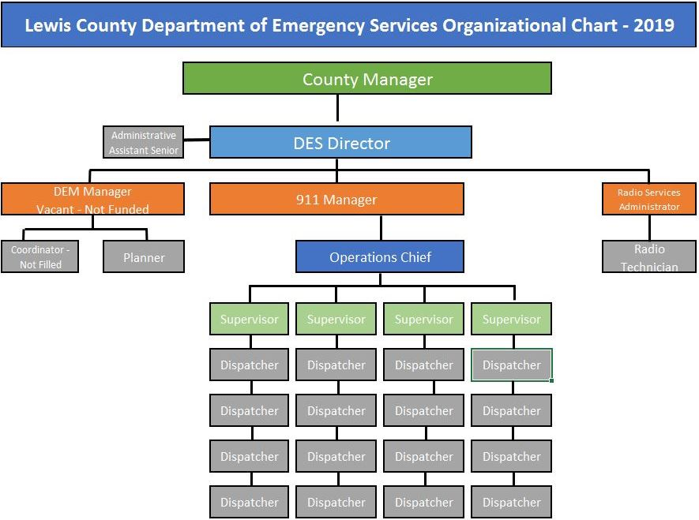

1. Mission & Purpose

Our Purpose is defined by our Mission which governs every employee’s conduct, interpersonal/professional performance, and work productivity. Our Mission emanates from our Vision, Ethical Values, Standards of Conduct, policies/procedures, rules, regulations, customs and practices.

The Mission represents a commitment to quality performance by all members. It provides the foundation upon which all operational decisions and organizational directives are based. The Mission signifies the commitment of the department to upholding the highest professional standards in providing a quality service to our community and the first responders.

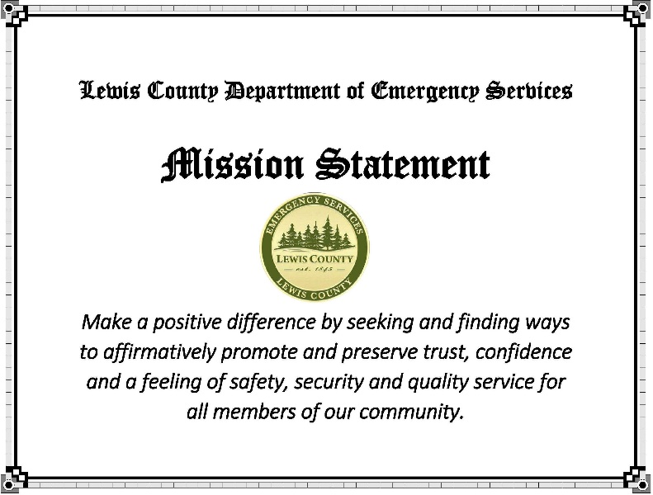

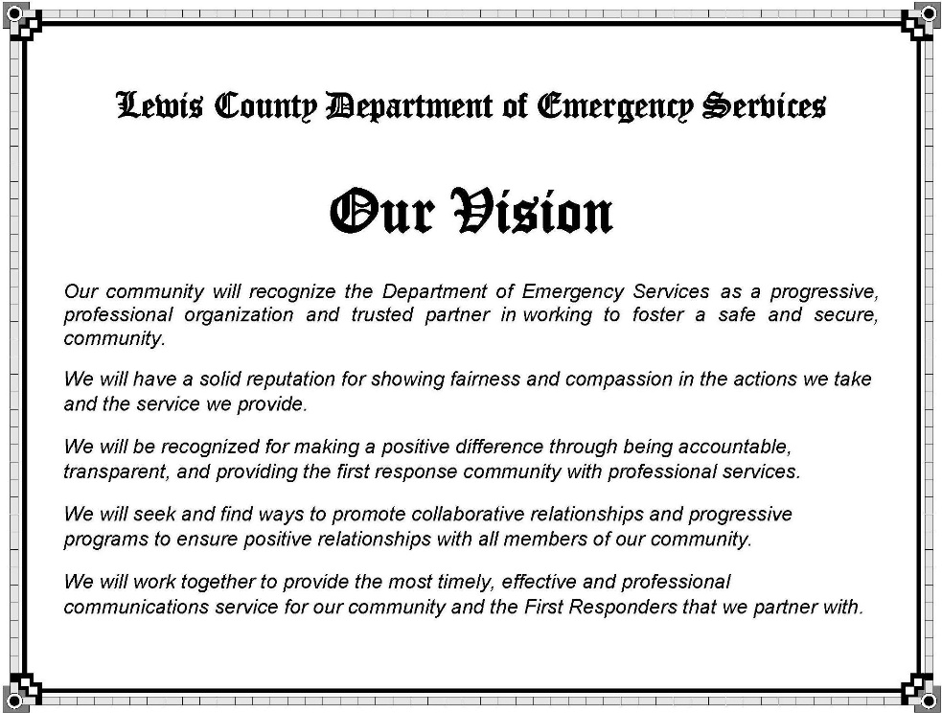The Department of Emergency Services Vision portrays an image of the Department from a citizen or community perspective. It plays a critical role in guiding the Department in fulfilling our purpose and achieving our mission.

2. Ethical Values

The Departmental Ethical Values are the most powerful internal control standard for governing conduct and behavior. Evaluating employee performance against the standards expressed and implied in our ethical values is a legitimate and important business necessity.

The decisions we make and actions we take shall be based upon carrying out our duties and responsibilities in a manner that is Trustworthy, Responsible, Respectful, Fair and Caring.

3. Performance Directed Management Program

In March, 2017, Director Steve Mansfield implemented a new Performance Directed Management program. The program encourages accountability and commitment from all members in finding creative and innovative ways to meet our mission.

The first year program was divided into four phases of implementation. The phases and are: Governing Directives, Measurement & Rating System, Establishing Accountability and Commitment, and Risk Mitigation.

Benefits**:**

This system provides for accountability, transparency, timeliness, effectiveness, and collaborative relationships with the community and first responder partner agencies.

It will lead to enhanced recruitment, streamlined training, staff retention, and increased efficiency in all aspects of the 911 Communications program.

The performance directed management system is a key component to ensuring our purpose is fulfilled and we meet our Mission on a daily basis.

4. Leadership Framework

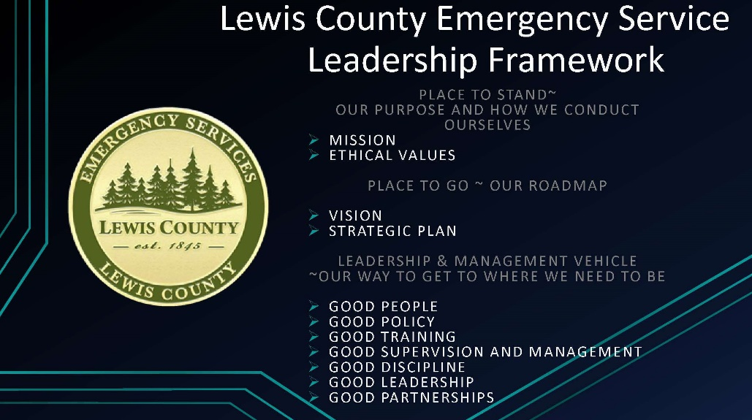

**III.** Administration

B. Personnel

1. Radio Services Division

1. **Staffing Levels**

The Radio Services Division consists of two employees, one Administrator and one Technician. Both employees are responsible for the service and maintenance of the radio system used by Lewis County Departments, User Group Organizations and the 911 Communications Center. The radio system not only serves the first responder community, it also serves entities like Public Works. The radio system includes radios used to communicate and the necessary infrastructure required to transmit the communication. The Radio Services Division services portable radios (hand-held), mobile radios (in-vehicle radios), and 22 radio tower sites.

The Radio Services Division has 4 contracts to service and maintain radios for outside entities. The contracts are with the City of Chehalis, Winlock Fire Department, Boistfort Fire Department, and the City of Napavine.

The Radio Services Division staff facilitated the installation of new phone and radio system software upgrades and coordinated issues with vendors.

1. **Training**

Radio Services Division staff completed Advanced System Training to increase proficiency of radio system self-maintenance. Both employees also completed their required Safety and Rescue Training Course covering tower climbing safety.

2. 911 Communications Center Division

**a. Staffing Levels**

In 2018, the division’s employee hiring, training and retention procedures were restructured. The restructuring included clarification of job descriptions, development of annual employee expectations and a new annual performance evaluation process.

The current 911 Communications Center staffing model consists of the following FTEs:

16 Telecommunications Officers

4 Telecommunications Officer Supervisors

1 Operations Chief

1 Administrative Assistant

1 Manager

.5 Director

**23.5 Total FTEs**

Over the last several years, staffing levels of the 911 Communications Center have varied between 50 - 75% of capacity.

In 2017, staffing levels began and ended with 12 fully trained Telecommunications Officers and 2-3 Trainees, maintaining a staffing level between 70-75%. In order to maintain minimally acceptable staffing levels to operate the 911 Communications Center, previously retired staff occasionally augment the current employees. In 2018, we ended the year with a total of 19 FTEs, with 6 of those being trainees.

Retirements in 2016 and 2019 contribute to the overall replacement needs; it is anticipated it will take 3-5 years to re-establish a stable staffing level.

**b. Collective Bargaining Agreement (CBA)**

Since 2017, the 911 Communications staff has been represented by a Guild. The previous CBA, represented by Teamsters, expired on December 31, 2015. Unresolved issues from past negotiations and the changes instituted by the current Performance Management structure have required an extensive overhaul of the CBA. Negotiations have been underway to reach a new agreement since 2017. Currently many issues have been resolved; however, unresolved impasses persist. Management is continuing into 2019 with a mediator in an effort to reach a new agreement.

**c. Hiring Process - Move to “Open Application” Process**

In 2018, the position announcement process was revised. Position announcements for hiring remain open until all positions are filled and a pool of new applicants is developed. The move to an “open application” process is working to address the need to have a ready list of candidates to select from when the need arises.

Benefits: Staff retention issues are being partially resolved by the initiation of a consistent and formal hiring practice.

**d. Testing, Background Investigations and Hiring Procedures**

In 2018, the methods in testing, hiring and conducting background investigations for Telecommunications Officer (TCO) applicants were evaluated. A standardized scoring procedure was developed and applied to the oral board interview process. As candidates for the position of TCO move forward in their application process, they complete a comprehensive background questionnaire. Information gathered from the initial application and background questionnaire is used to complete a background investigation prior to the candidate being offered a position.

Benefits: Adopting a standardized testing and background investigation process has increased the probability new hires will become successful TCOs. It also provides a smoother process to achieve a full staff roster and reduces the time being spent hiring and training new employees.

**e. Training**

1) **New Hire Training**

Prior to 2018, the new employee training program duration was approximately 11 to 12 months. In 2018, updates and revisions were made to standardize the training program to reduce training time by an average of 3-4 months.

The qualifications and technical training is extensive for the position of TCO. To improve training, the Telecommunications Officer Academy program was instituted two years ago and is beginning to show signs of success. The training now follows a systematic process to ensure each TCO is qualified to perform their essential job functions at a high level. The table below lists the Lewis County training requirements for TCOs:

|  |  |  |
| --- | --- | --- |
| (1) Required Classes | (2) TCO Academy | (3) On-The-Job Training |
| TOC I & II – 80 Hours | Spillman – 120 Hours | Call Taking - 6 Weeks |
| ACCESS – 8 Hours | Call Taking – 80 Hours | Fire – 4-6 Weeks |
| Emergency Medical Dispatching – 40 Hours | Law - 40 Hours  Fire - 40 Hours | Law - 8-10 Weeks |
| **Totals: 128 Hours** | **Totals: 280 Hours** | **Totals: 18-22 Weeks** |

|  |  |  |
| --- | --- | --- |
| *New Employee Training Savings | | |
| *Calculation figures include salary + benefits | | |
|  | **Savings Total (4 mo.)** | **Total Savings**  **Per Employee** |
| **Trainer**  ($7,103) x 4 mo. | $ 28,412 |  |
| **Trainee**  ($5,867) x 4 mo. | $ 23,468 |  |
| **Total Savings Per Trainee** (approx.) | | **$ 51,880** |

Benefits: The more efficient training program has allowed TCOs to advance more quickly toward being able to perform their duties without direct supervision. The reduction in training time from an average 12 months to an average 7 months also frees up the trainer resulting in a substantial budget savings. Providing a better training program is resulting in more efficiency, more experienced TCOs on the consoles and a net savings to the budget.

2) **On-going TCO Training - Target Solutions Program**

We invested in a comprehensive training program that helps us deliver, track and notify staff of training. In 2018, we delivered over 1,080 hours of training to our TCOs. Automatic training reminders are setup to ensure important training and certifications do not lapse.

Benefits: Helps ensure training needs are documented and provides a record of training verification. In 2018, our mandatory Human Resource training completion rate went from 35% to **90%**. Training expectations and accountability has had a positive impact in providing the consistent delivery of professional services.

3) **Supervisor Training Program**

In 2018, management continued to develop the supervisory training program implemented in 2017. New training was added to include Concepts of Due Process, Just Cause, Supervisory Just-In-Time Reports, Supervisory Note, Documented Warning, Self-Improvement Plan, Corrective Action Flow chart and Supervisory Weekly Report revisions.

Benefit: Provides management and supervisory staff with consistent tools to manage poor performance and recognize exemplary employee performance. This uniformity provides for a more stable work environment, benefits employee development and service to the community.

**f. Quality Assessment & Improvement Program**

We implemented a quality assurance program in 2018. The program reviews employee performance issues in three separate categories:

* Call Taking
* Fire/EMS Dispatch
* Law Dispatch

Each month TCOs are randomly audited. National Emergency Number Association (NENA) standards are applied. TCOs measure well above the 90% NENA standards in all categories.

We then cross-check the service provided against our policies, procedures and training programs.

Benefits: Identifies both poor and exemplary performance, tracks training needs, keeps up with changing service needs from our first responders and identify gaps in our service program; supervision & management; policy and procedures.

**g. Performance Evaluation & Review**

In 2018, the Department of Emergency Services completed the Performance Evaluation, Review and Expectations phases of the Performance Management Program. Policies relating to these sections of the program were also updated.

Benefits: Provides a consistent and timely method to recognize, address and improve performance in a manner that ensures employee and organizational success in achieving our Mission.

**h. Recognition**

**1) Outstanding Performance**

In 2018, we started an employee recognition program to acknowledge and show appreciation to those who individually or as a team excelled in their service/performance. Our primary area of focus was to recognize individuals or teams who meet our Mission and exemplify our Ethical Values.

The recognition categories are:

|  |  |
| --- | --- |
| Performance Recognition Categories | |
| **Mission Maker** | Performance that makes a positive difference in meeting our Mission to promote trust, confidence and quality service |
| **Employee of the Year** | The Employee of the Year Award is achieved by consistently demonstrating superior performance that supports/furthers the mission and our values. |
| **Quality Performance Award** | The Quality Performance Award is achieved by having the highest combined scores from the Quality Assurance Program. |
| **Critical Incident Award** | The Critical Incident Award is achieved by exhibiting outstanding performance during a critical incident. |
| **Teamwork Award** | The Teamwork Award is achieved by the squad or team of people (two or more) exhibiting outstanding performance during a critical incident. |
| **Most Improved** | The Most Improved Award is achieved by a person exhibiting major performance improvement over the performance period. (Not awarded in 2018). |
| **Availability for Work** | The Availability for Work Award is achieved by a person exhibiting outstanding availability for work. (Not awarded in 2018). |

**2) Non-Monetary Merit Program**

To accompany the Mission Maker Performance Recognition program we developed a category of what we call Non-Monetary Merit Awards. The following is a list on non-monetary items awarded to employees for outstanding performance:

* Shift Selection (1)
* APCO Conference (2)
* Parking Spot (1)
* Family Day (2)
* Training Day (2)

Benefits: Provides employee recognition, promotes our Mission, and shows interested stakeholders how our employees are making a positive difference in our community and with first responders.

**3) 2018 Recognition Awards:**

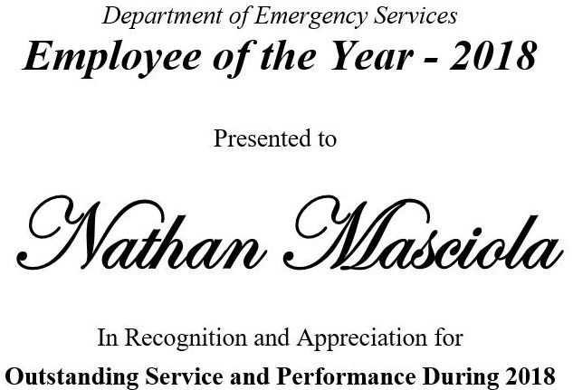

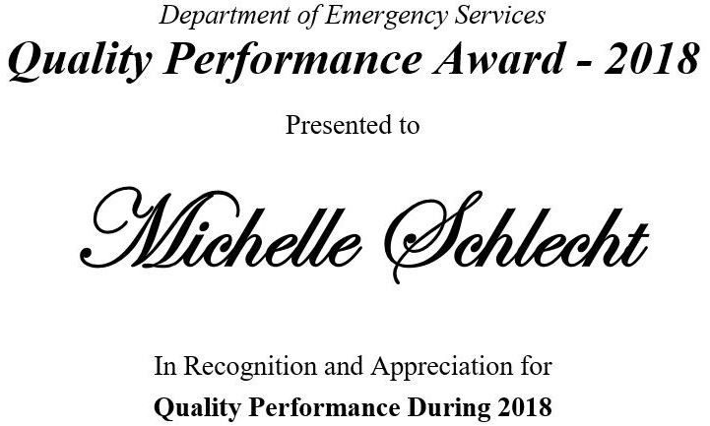

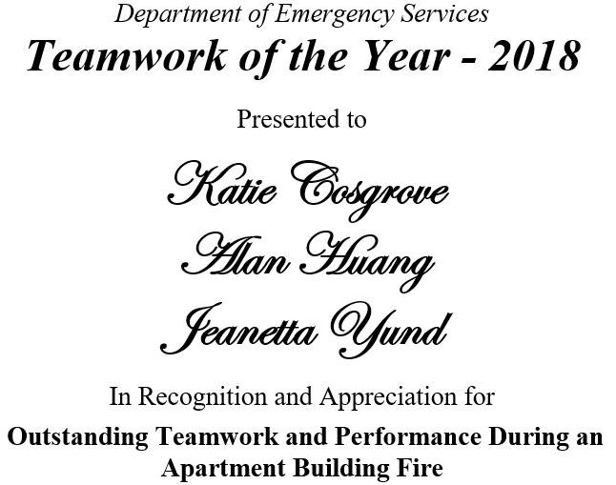

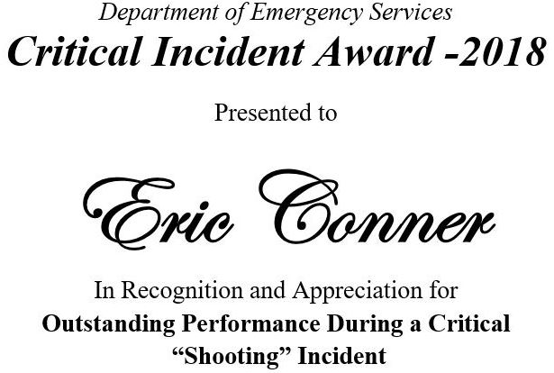

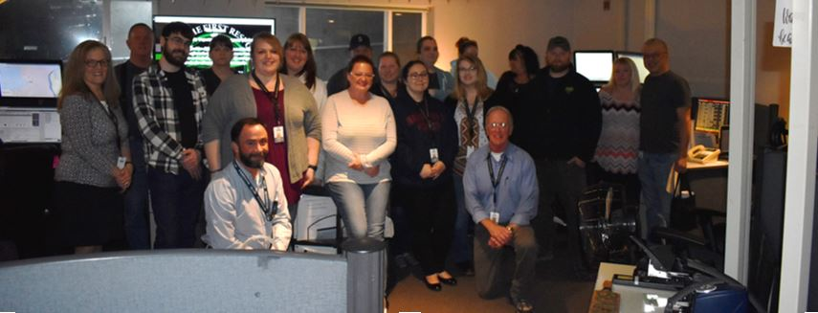

C. Policy & Procedures

In 2017, the Department of Emergency Services implemented several new sections of the policy manual to provide consistency and direction into the overall operations of the Department.

In 2018, the section of the manual pertaining to 911 Communications was further reorganized into two separate sections that follow the Commission on Accreditation for Law Enforcement Agencies (CALEA) policy format. Policies are categorized and implemented that closely follow the CALEA best practices and standards for communication agencies across the nation. The work on these policies and procedures is ongoing.

The Fire Services and Law Enforcement organizations each have separate procedural manuals that outline the operational agreements for how the 911 Communications Center will provide services. These procedures are specific to the organizational service goals and were officially adopted into procedures of the Lewis County 911 Communications Center.

Benefits**:** Good policy/procedures helps to insure efficiency of operations and services by providing consistency and continuity in what we do.

D. Interlocal Agreement (ILA) & Combined User Committee (CUC)

**1. History**

A coordinated program of shared dispatching services began in the mid-1980s. No early records of this period have survived, except an unsigned copy of a 1995 Interlocal Agreement. It established the original agency fees and indicated shared costs for the radio equipment, management services, and equipment replacements cost would be identified in the future. A program began for law and fire services to work with the Communications Center administrative staff to develop an operation manual for services provided by the Center.

During the next two decade Operating costs for the Communications Center were shared among users. Lewis County that owned the equipment was left to cover the supporting infrastructure. This division of costs remains the same on the date of this report.

In 2017, The Lewis County Board of County Commissioners (BOCC) began discussing a shared form of governance that allowed for a more direct role of the partner agencies in managing and having input into the operations of the Communications Center, along with paying for the full operating costs. They also began discussions on ways partner agencies could fairly contribute to the maintenance and operating costs of the countywide communications infrastructure.

**2. Partner Agencies**

The partner agencies managing or receiving services from the 911 Communications Center (30 jurisdictions, three county departments, and one Emergency Medical Service provider) are included in a 2018-19 Interlocal Agreement (ILA) that was ratified by all parties by June, 2018. They include the following:

|  |  |  |
| --- | --- | --- |
| Lewis County | Morton (Police Department | LC Fire District 13-Curtis |
| Lewis County  Sheriff’s Office | LC Fire District 1-Onalaska | LC Fire District 14-Randle |
| Centralia  (Police Department) | LC Fire District 2-Toledo | LC Fire District 15-Winlock |
| Chehalis (Police Department) | LC Fire District 3-Mossyrock | LC Fire District 16-Doty |
| Chehalis (Fire Department) | LC Fire District 4-Morton | LC Fire District 18-Glenoma |
| Napavine  (Police Department) | LC Fire District 5-Napavine | Cowlitz-Lewis # 20 |
| PeEll (Marshall’s Office) | LC Fire District 6-Chehalis | Riverside Fire Authority |
| Winlock (Police Department) | LC Fire District 8-Salkum | Lewis County DEM |
| Vader (Police Department) | LC Fire District 9-Mineral | Lewis County Public Works |
| Toledo (Police Department) | LC Fire District 10-Packwood | Lewis County  Coroner’s Office |
| Mossyrock  (Police Department) | LC Fire District 11-PeEll | AMR (separate contract) |

**3. Interlocal Agreement (ILA)**

The 2018-19 Interlocal Agreement (ILA) differs from standard agreements in that it outlines a shared work program. The end result is establishing a shared user participation of all costs associated with providing communications. Cost share items include radio sites, leases, maintenance and equipment replacement, as well as dispatching services from the 911 Communications Center.

All partner agencies and the County agreed to the ILA work program with milestones to share the entire system costs. It is anticipated that once the shared work plan goals have been achieved, a more traditional agreement would replace the 2018-19 ILA.

**4. Combined User Committee (CUC) Creation**

A major section of the Interlocal Agreement (ILA) was the establishment of a user group organization called the Combined User Committee (CUC). The purpose of this committee is to bring the partner agency representatives (one for each agency) together at quarterly meetings. They establish functioning Fire/Law groups to update Law and Fire Manuals, establish a Budget Review Committee, and ensure information is relayed to the partner agencies. Separate votes are taken for the Law and Fire disciplines when decision items affect just one group. Any budget items brought before the committee have to be submitted to the 911 Communications Manager at least 14 days prior to a vote to ensure adequate notice to all parties.

Combined User Committee (CUC) Flow Chart

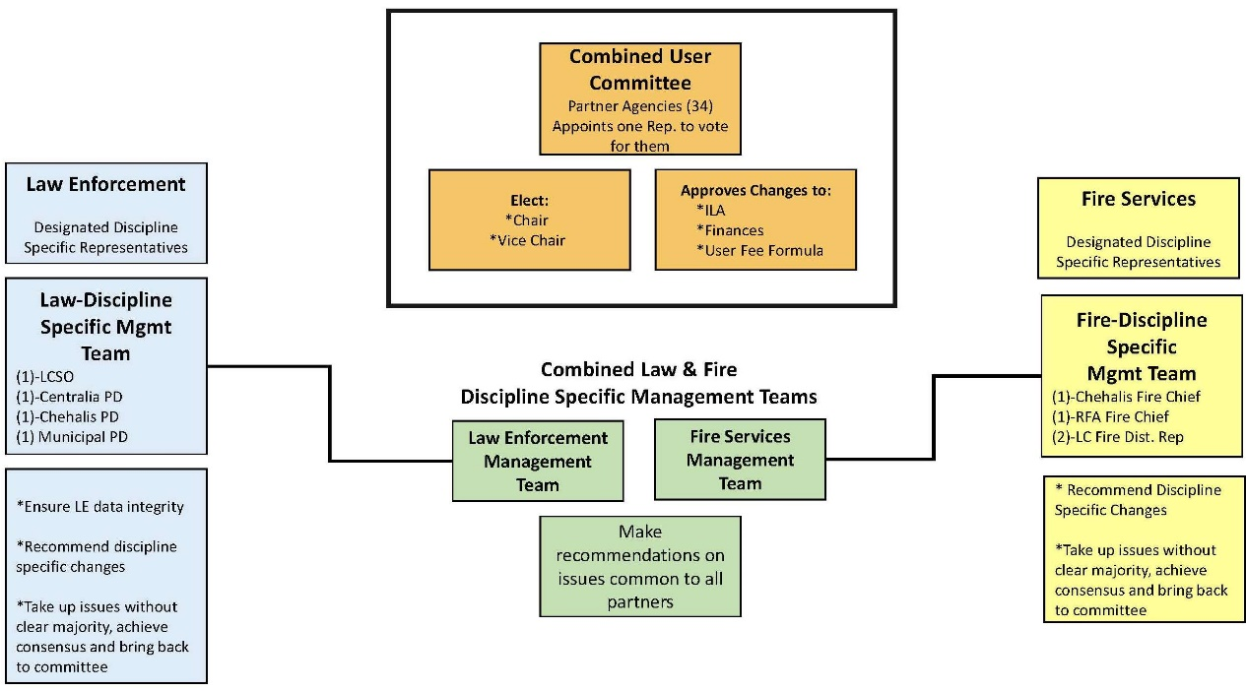

**5. CUC 2018 Accomplishments:**

* Committee established, representatives appointed, and officers elected.
* Quarterly meetings held March 30, July 30, and October 11
* Approval of rates (fire/law) to be used in the 2019 budget
* Appointment of a Budget Subcommittee, review of budget proposals, completion of budget process.
* Discussion to establish the scope of an Infrastructure Communications Study (update 2005 ADCOMM study for today’s technology; fire and law sections only). Project proposal went out to bid in December 2018, with contracts signed early in 2019. Anticipated completion date is December 2019.
* Grant application submitted to TransAlta for Paging system, Phase I-West Side, approximately $100,000 – Originally submitted September 30, 2018, resubmitted December 2018, and again for January 2020.
* Some CUC representatives presented their interest in pursuing regionalization of dispatching service with TCOMM, a non-profit based Thurston County dispatching organization. Their proposal was brought to the Board of County Commissioners. Exploration of that option will continue into 2019.
* Capital Facilities Plan Consultant engaged. The Lewis County Board of County Commissioners have contracted a consultant firm to develop a plan for a new 911 Communications Center. The project is underway and expected to be in 2019.
* Development of a Strategic Plan – Several items listed in the Strategic Plan have been placed on hold due to the exploration of regionalizing dispatch services. Consideration of evaluating the current Communications facility is delayed until other decisions are made.

E. Strategic Plan

A copy of the original ILA Strategic Plan accepted by the Fire and Law representatives included in the ILA on January 26, 2018 (fully executed by all entities on July 11, 2018):

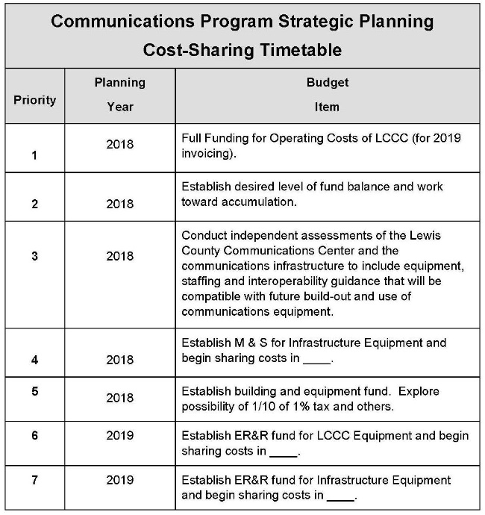

The Strategic Plan document has changed considerably from the beginning of the year until the end of the year, with the most significant change being the exploration of contracting out the dispatch services. The original Strategic Plan (2017) was created believing everyone was committed to continue with services provided by Lewis County. During the two-year evolution of the CUC group, shifting goals of some agencies within the collective team have changed the timeline as indicated below on the updated Strategic Plan (items are color-coded for easier identification):

**Green** – Completed **Black** – Not currently active due to higher priority items

**Red** - In the process of completion **Blue** – New items under consideration for the ILA update in 2020

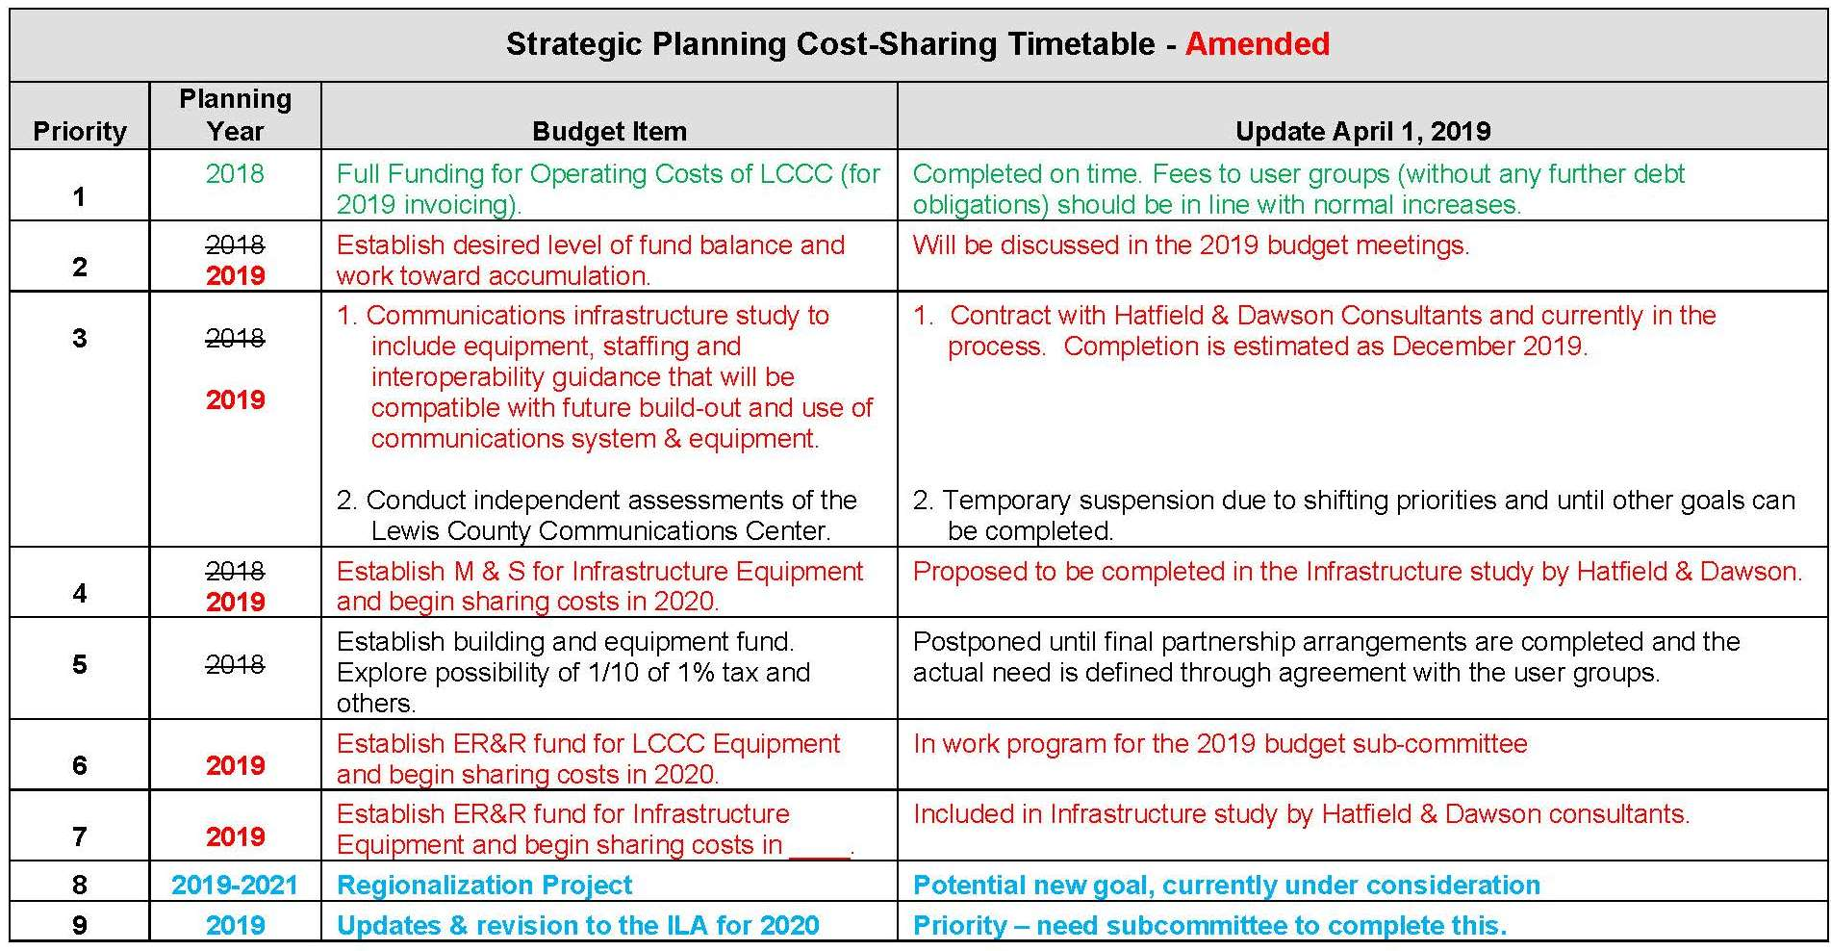

V. Budget & Finance

A. Radio Services

The following represents the 2018 Radio Services Operations Budget (This does not include capital funds that were expended for equipment, also see Section VII, “Capital Improvements” section):

|  |  |  |  |
| --- | --- | --- | --- |
| **2018 Radio Services Operations Budget** | | | |
| **Revenue**: |  |  |  |
| User Fees: | $ 281,360 |  |  |
| HLS Grant: | 32,000 |  |  |
| LC Current Expense Support: | 20,000 |  |  |
| **Total Revenue**: |  | **$ 333,360** |  |
| **Expense:** |  |  |  |
| **Total Expense:** |  | **333,360** |  |
| **Total 2018 Radio Budget:** |  |  | **$ 333,360** |

B. 911 Communications Center

**1. Historical Revenue and Expenditures (2013-2018)**

The charts below represent the history of the 911 Communication Center’s revenue, expenditures and allocated rates from 2013-2018. While revenue fluctuated and expenditures increased, user fees remained relatively flat at a 1% increase from 2013-2015.

During the 2013-2015 years, the County, at the request of the user group, used reserve funds totaling $490,078 to balance the shortfall. In 2016 and 2017, the user fees were increased by a 10% flat rate to balance the budget.

By the end of 2017, an advance of $100,000 from the County was necessary to meet expenses in the final quarter (until revenue was received in the first quarter of 2018; this advance will need to be paid back).

By 2018, the reserve funds were depleted and unfilled TCO positions created a position net balance.

**Historical Revenue and Expenditures Chart (2013-2018)**



**2. 2018 911 Communications Center Operating Budget**

**a. 2018 Revenue**

The Lewis County 911 Communication Center has two primary funding sources:

* User Fees
* 9-1-1 Sales and Use Taxes

User Fee revenue comes from user groups, e.g., Law and Fire Services.

*Enhanced 911 Sales and Use Tax is a monthly tax on phone lines, wireless phones and Voice-Over-Internet Protocol (VoIP) services.

**\*Enhanced 911 Sales and Use Tax is declining as landline use decreases.**

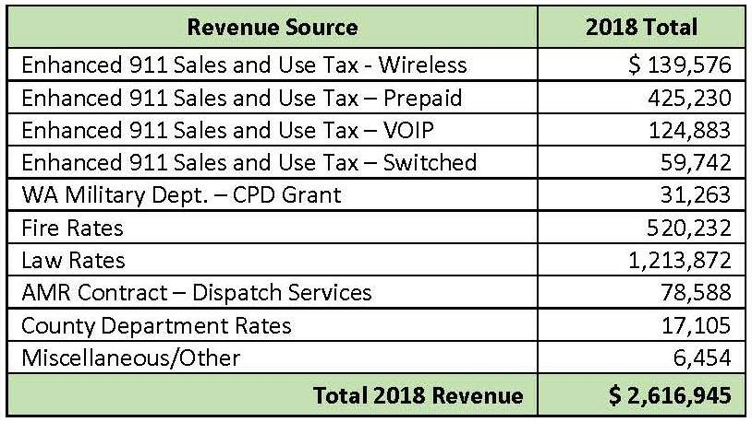

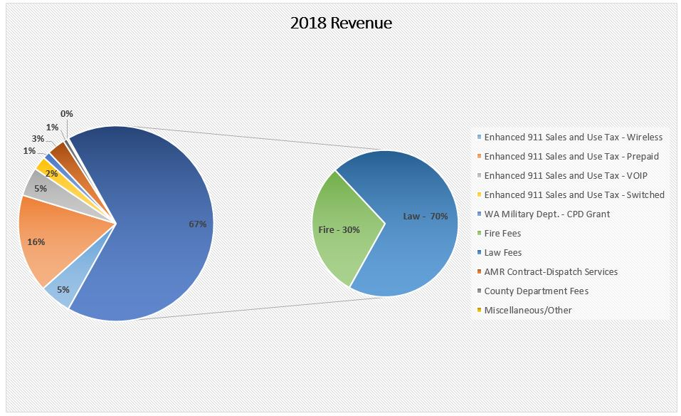

The smaller graph is a breakdown of the Law/Fire user percentages groups

The larger graph shows the total revenue for the Lewis County 911 Communication Center in 2018

**b. 2018 911 Communications Center Expenditures**

* Overtime expenses were reduced from $222,775 in 2017, to $142,264 in 2018.
* The $80,511 reduction of overtime in 2018 was the result of direct oversight and best practices.
* **The 2018 overtime reduction was a 36% savings.**

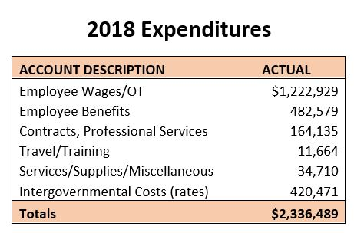

***(2018 Expenditures were rounded up $1 in Excel)***

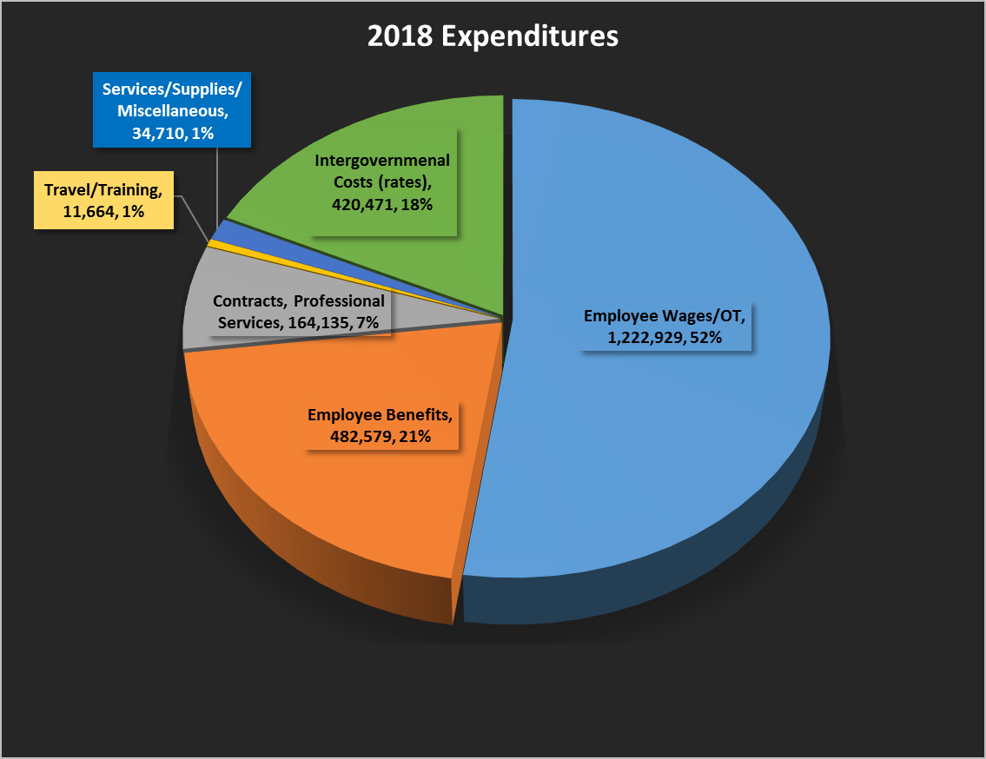

**c. 911 Communications Center Operation Budget Fee Distribution**

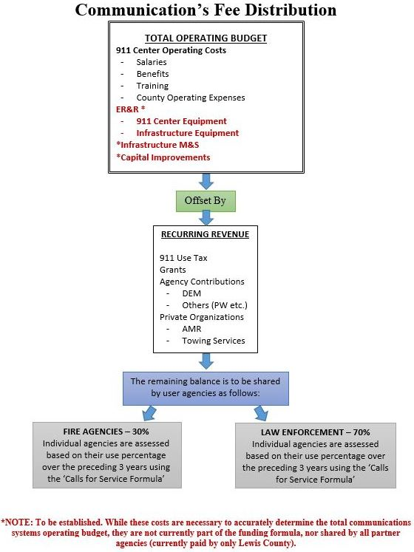

**d. 2018 User Fees**

User Fees only pay towards the 911 Communications Center budget. At this time, only Lewis County supports the infrastructure expense.

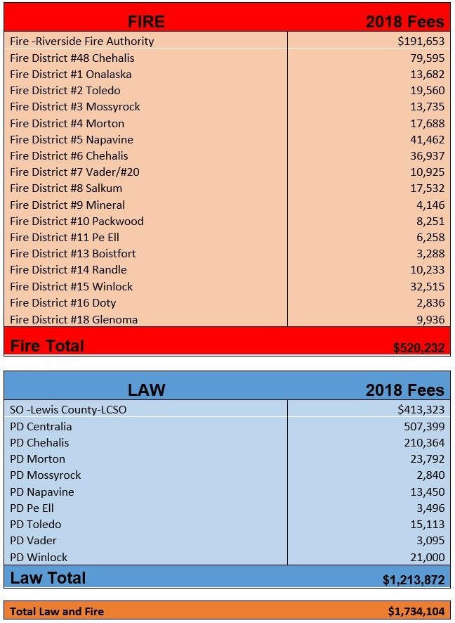

VI. Services

A. Radio Services Division Services

Radio Service staff maintain and service a network of 22 communications sites throughout the county that provide first responder radio coverage.

Additionally, they provide local trouble-shooting services (and limited technical assistance) to outside vendors to assist in identifying and making emergency repairs when equipment fails in the Communications Center.

In 2018, they continued maintenance of mobile, portable and fixed base radio equipment for the county and agencies supported by contract.

The Radio Services Administrator manages the Homeland Security equipment grants. This includes researching models, purchasing equipment, preparing/maintaining records, and includes installation of anything pertaining to the backbone communications system. (Contract records are maintained by the 911 Communications Center Office.)

Radio Service staff also provide technical assistance for the ham radio program (ARES, RACES and HEC).

Staff continues to use a RICI remote access (grant funded project - $22,000) to trouble shoot and make adjustments to remote site equipment. The program has already saved over $40,000 in travel and overtime that would have been necessary without the new program. It has now been expanded to include IP backhaul for selected radio circuits.

B. 911 Communications Center Division Services

**1. 2018 911 Communications Center Services Provided**

The 911 Communications Center performs communications services for all Lewis County response groups.

**a.** **Total 2018 Calls/Dispatch Services**

Three types of services were tracked for this report: Dispatch Events, Telephone Call Volume (emergency and administrative), and 911 Disconnects (hang-ups). In 2018, the total number of these three tracked services was 222,394.

**b. 2018 Total Dispatch Events**

The total number of dispatch events for 2018 was 76,612. Dispatch events are initiated in a variety of ways. The most common ways events are generated is by a citizen calling and reporting crime or fire, an officer conducts a traffic stop, or a citizen calling to request medical services. Dispatch events are broken down into four categories: Law, Fire, Traffic Stops and Miscellaneous Events (e.g., Coroner, Public Health, and Chaplain). This equates to an average of 210 dispatches daily.

**c. 2018 Telephone Call Volume**

The total Telephone Call Volume for the 911 Communications Center was 142,438 calls. These calls are broken down into four separate categories: 911 Calls, 7 Digit Emergency Telephone Calls, Administrative Calls, and Outbound Calls. The 7 Digit Emergency Telephone Calls are calls received on the non-emergency (360) 740-1105 but end up being an emergency call.

**d. 9-1-1 Disconnects**

Calls are received at the 911 Communications Center through 9-1-1 and on (360) 740-1105. Sometimes calls can be dropped or the caller suddenly hangs up the phone. Whatever the reason, any disconnected call that might be an emergency, requires an operator to call back to insure the person’s safety. Staff continues an active campaign to educate the public not to hang up if they accidentally dial 9-1-1.

In 2018, the 911 Communications Center processed 3,344 disconnected calls. The returned calls utilized vital resources and resulted in the use of approximately 112 hours of staff time.

**e. 2018 Inquiries**

In 2018, the Lewis County 911 Communications Center did not receive any Inquiries (grievances) from the public. However, there were 49 grievance inquiries from response groups.

Each inquiry was thoroughly investigated and resulted in a finding of:

* Sustained
* Sustained with Mitigating Factors (A finding of Sustained with Mitigating Factors would be the result of an inquiry with merit but the resulting investigation revealed the actions during the incident were reasonable.)
* Not Sustained
* Unfounded.

The 49 inquiries resulted in the following findings:

17 Sustained

18 Sustained with Mitigating Factors

4 Not Sustained

10 Unfounded

The inquiries received came from several agencies. Fire district inquiries make up 88% (43) of the total grievances, while Law Enforcement made up the remaining 12% (6). The professionalism and high level of service provided by our Telecommunications Officers can be seen clearly in considering only 49 inquiries were received out of 76,612 dispatch events in this area. This results in a **99.94%** **services satisfaction rate**. The 911 Communications Center surpasses national standards set forth by the National Fire Protection Agency, National Emergency Number Association and the Association of Public-Safety Communication Officials.

**2. Community Outreach**

|  |  |
| --- | --- |
| Community outreach is an essential part of our mission. We strive to identify new and innovative ways to disseminate information and provide public education. | A $5,000 portion of the CPD Grant funds most of our community outreach efforts. |

|  |  |
| --- | --- |
| As part of our goal to provide public education, we participated in the 2018 Safety City Program. This program helps to educate the community youth about emergency services. In 2018, we also went to three elementary schools to provide public education to students. |  |

|  |  |
| --- | --- |
| Our community outreach efforts continued at the Southwest Washington Fair. At our information booth, we provided activities focused on teaching youth about public safety and handouts centered on emergency services for adults. Staff from the 911 Communications Center were on hand to answer general questions throughout the duration of the fair. |  |

|  |  |
| --- | --- |
| Facebook has proven to be an effective platform for reaching out to the community. At the time of this report, the Lewis County 911 Communications Facebook page has 6,255 followers.  The Facebook page is currently used to update the community with information regarding major events, road closures and burn bans. It is also used to inform the community of employment opportunities in the 911 Communications Center and upcoming community events.  Our Facebook page contains links to other valuable resources in the community including the Lewis County website. |  |

**3. Public Records Request**

Public records request continue to be a time consuming labor-intensive operation. In 2018, the 911 Communications Center staff spent over 525 hours processing a total of 321 records requests.

**This workload requires one-quarter of an administrative support FTE.**

**4. Lewis County Alert**

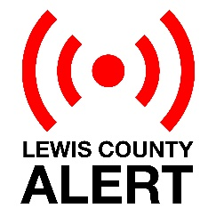Lewis County Alert is the primary alert and notification system used to broadcast messages to two groups:

* Lewis County citizens
* Lewis County employees and response organizations

a. **Lewis County Citizens Group**

The Lewis County Citizens Group receives messages providing emergency information to the public as well as important community safety information. These alerts can go out to all of the contacts in the Lewis County Citizen Group. There are primarily two different groups that receive messages in the Citizen Group:

* + **Landline telephone numbers**

There are 20,528 landline telephone numbers provided by the local phone service through the Lewis County Alert vendor.

* + **Self-registration numbers**

Currently there are 4,345 on-line registrations. These individuals have provided their cell phone, home phone, and/or email information. Individuals who self-register are able to determine how they prefer to received their messages e.g., home phone, E-mail, mobile devise.

b. **Lewis County Employees/Responder Group**

The Lewis County Employees/Responder Group is a messaging system within Lewis County Alert that allows groups to send messages. The messages sent on the Lewis County Employee Group are administrative in nature and are managed by assigned group administrators. Examples of these groups are:

* + Search and Rescue
  + Public Health
  + ARES Ham Radio
  + Media
  + Critical Incident Stress Management Team

|  |  |
| --- | --- |
| **Tests and Notifications Summary - 2018** | |
| **Category** | **Activations** |
| System Activations (Responder Groups) | 252 |
| System Tests | 1,237 |
| Community Emergency Notifications | 6 |
| **Total 2018 Lewis County Alert Activations** | **1,495** |

Tests and Notifications are messages sent to individuals, responders and employee groups.

|  |  |
| --- | --- |
| **Date** | **Notice Type** |
| 03-28-18 | Napavine water line break (main) |
| 04-04-18 | Tacoma Power Exercise, Alert test, self-registered group |
| 05-30-18 | Power Outage |
| 07-31-18 | Miriam Fire |
| 10-18-18 | Drop, Cover + Hold Drill |
| 12-27-18 | 911 Failure |

In 2018, six Lewis County Citizen Group Alert messages were sent to the community.

VII. Capital Improvements

All expenses in this section have been paid by Lewis County, without contribution of the User Group. The Strategic Plan includes future sharing of these costs.

A. Department of Emergency Services (DES)

* Update of 2005 ADCOMM Communications (Infrastructure) Study
  + Prepared Scope of Services, limited to Law & Fire communications
  + Developed RFQ for advertising for a Consultant to do the project
  + Published RFQ and reviewed submitted applications
* Submission of TransAlta Grant application for Fire Services Paging System ($100,000 requested, with local match). A grant application was submitted to TransAlta in September, 2018. Funding was depleted so the Board asked us to update and resubmit in December 2018. (That application is being considered for funding in January 2020.)

**Total project cost: $200,000**

B. Radio Services Division

The 2018 Capital Projects Radio Services Division assisted with include the following:

* **Back-up Communications Center**
* Established the technical requirements to create a secondary 911 Communications Center at the Central Shop
* Vetted and purchased radios, antennas and associated equipment for the project)

|  |  |
| --- | --- |
| **Back-up Communications Center Expenses** | |
| Tower: | $ 2,600 |
| Radios | 16,695 |
| Antennas/parts | 6,191 |
| Facilities – Labor | 378.67 |
| **Project total** | **$ 25,864.67** |

* **Chehalis Ridge Radio Site Development**

Currently relocating the current Centralia-Chehalis police department radio site to a new location capable of expanding to include LCSO, Fire and RFA. Anticipated to be operational by the end of 2019:

* Establish the technical requirement for the new site
* Completed requirements needed for site prep and monopole construction to prepare for engineering firm certification.
* Provided engineers with land and technical issue resolution as needed.
* Completed Antenna Structure Registration requirements with the FCC.

|  |  |
| --- | --- |
| **\*Chehalis Ridge Site Development Expenses** | |
| Engineering | $ 32,369 |
| Property Purchase | 75,000 |
| Easements | 60,000 |
| **Total 2018 Expenses** | **$ 167,369** |

*Estimated additional development costs include building, genset, road, radios & misc. equipment = $100,000

Benefits: Allows increased radio communications coverage for fire services and law enforcement agencies.

* **\*Infrastructure Study Technical Assistance**
* Provided the Emergency Services Director with technical parameters for the update of the 2005 ADCOMM radio infrastructure study)

*Costs pending consultant selection in 2019

* **New Radio Control System Installation - 911 Communications Center - complete**

* Finalized specs of the project and work with the Capital Facilities Committee to allocate necessary funds to provide for a new radio control system in the Communications Center consoles (8 stations) connected to 22 radio sites (approximately $500,000).
* Performed installation and optimization of the new radio control system until installation and compatibility issues were resolved
* Facilitated new phone system software upgrades and coordinate issues with vendors ($370,000).

|  |  |
| --- | --- |
| **Communications Center Radio Control & Phone Upgrade (NG911 Installation)** | |
| 8 Station consoles | $ 500,000 |
| New Phones/software upgrades | 370,000 |
| **Total Communication Ctr Upgrade** | **$ 870,000** |

Benefits: Utilizing on-staff technicians resulted in a substantial savings. The new consoles and telephone system are the latest technology and are ESI NET and NG911 compliant. This new equipment will be capable of serving the community for many years to come.

C. 911 Communications Center

* **Installation of new radio control system - complete**

Replaced existing 911 Communications Center consoles (8 stations) connected to 22 radio sites throughout the county (approximately $500,000). Funds provided by Lewis County Capital Facilities plan and completed by June 2018.

* **Installation of Next Generation 911 (NG911) - complete**

Installation of a NG911 upgrade to the Lewis County 911 system was completed in June, 2018. This was the biggest upgrade in Nationwide 911 since 1995 when “Enhanced 911” was implemented. This system is the latest technology that provides for the use of digital technology. Facilitated new phone system software upgrades and coordinated issues with vendors ($370,000).

Benefits: NG911 will enhance emergency number services to create a faster, more resilient system that allows voice, photos, videos and text messages from the public to the 911 network.

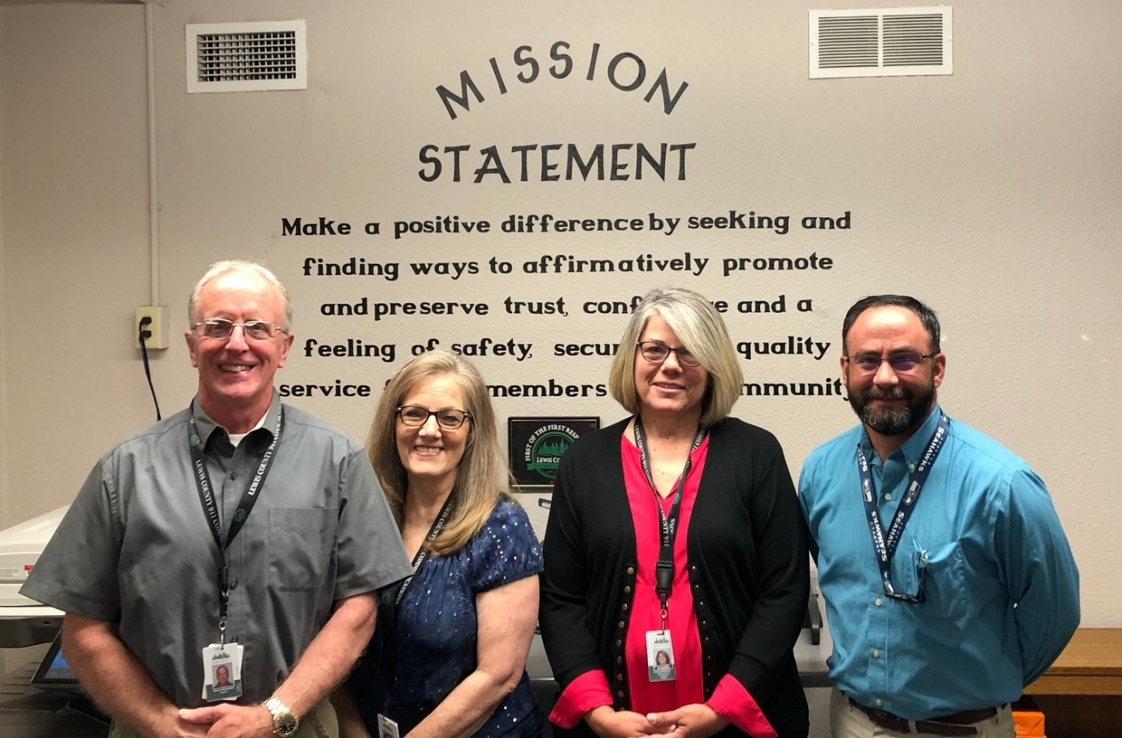

911 Communications administration staff, L-R: Steve Mansfield, Director; Patty Marsden, Operations Chief; Cheryl Millman, Administrative Assistant; Scott Smitherman, Interim Manager.