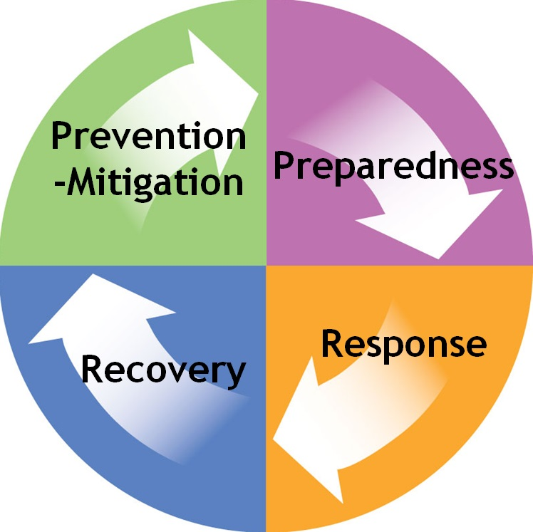
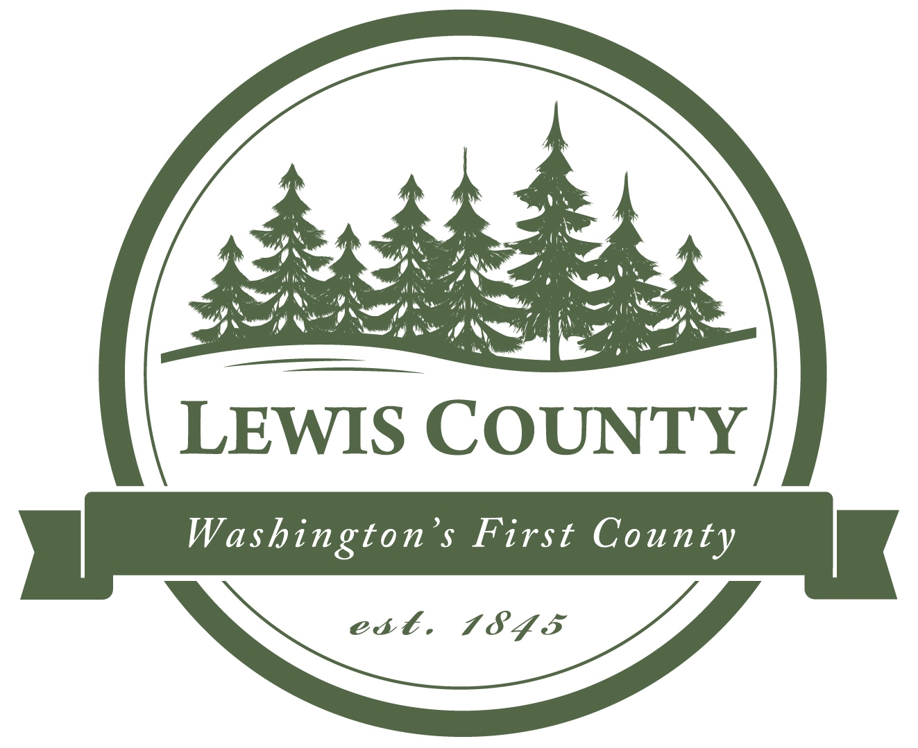
Lewis County
Emergency Operations Center (EOC)
351 NW. North Street, Chehalis, WA 98532
DEM@lewiscountywa.gov • Phone: (360) 740-1151 • Fax: (360) 740-1471

Andy Caldwell, Emergency Management Deputy Director

Cold Creek Wildland Fire
Situation Report

Current Situation Overview:

The Cold Creek Fire was discovered late Monday night (9/14/20) near Highway 12 approximately 30 miles west of Yakima, WA, and 6 miles east of the White Pass Summit on the Naches Ranger District of the Okanogan-Wenatchee National Forest. The fire is estimated at 50 acres and is burning in steep, timbered terrain. Firefighters worked on the fire all night; more resources, including two 20-person crews, four engines, tree fallers, and helicopters will be arriving today.

Overnight, fire behavior was very active with spotting and torching of single trees and groups of trees. State Highway 12 is closed due to the proximity of the fire. The public is urged to stay out of the area west of Clear Lake. An area closure, including roads and trails, will be put in place for public safety. No structures are threatened at this time.

The fire is burning on both sides of Highway 12, primarily to the south, but there are spot fires (approx. 5 acres) to the north.

Transportation Overview:

US Highway 12 is closed both directions over White Pass due to the fire. Eastbound traffic is stopped 13 miles west of the summit near milepost 138 at the junction of US 12 and SR 123. Westbound traffic is stopped at milepost 183, Oak Creek, two miles west of the Junction of SR 410. An estimated time to open the highway is not determined.

Current Evacuation Status:

Currently there are no Evacuation notices in Lewis County.

According to Yakima Valley Emergency Management Facebook page, Level 2 "Be Set" Evacuation Notices are in effect due to the Cold Creek Fire. The fire is located along the area of US 12 between Dog Lake and Clear Lake. The evacuation notice encompasses areas around Clear Lake and Rimrock Lake, including areas on both sides of US 12.

Emergency Management Monitoring:

DEM Focus:

- Event documentation
- Informational updates to Responders & Partner Agencies
- Distributing State and Federal information
- Ensuring all entities have been advised to document activities, use activity codes and keep supporting logs in order to capture as much reimbursement funding as possible.
- Advise impacted agencies to consider Declaration of Emergency when appropriate

Communications:

- Produce Situation Summary and distribute to all partner agencies
- Participated in State EMD daily Fire coordination meeting.
- Update EOC website, twitter and social media

Future Objectives:

- Be prepared to issue Lewis County Alert Evacuations, if necessary

Follow the Cold Creek Wildland Fire at: https://inciweb.nwcg.gov/incident/7198/

