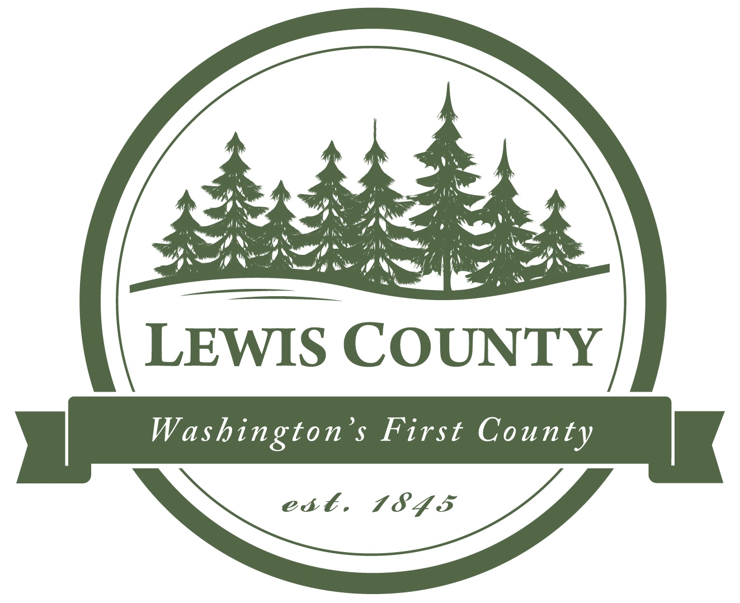

Lewis County Division of Emergency Management

351 NW. North Street, Chehalis, WA 98532 DEM@lewiscountywa.gov Phone: (360) 740-1151

Andy Caldwell, Deputy Director

NEWS RELEASE
For Immediate Release
News Release No. 3
Date: March 19, 2020
Contact: Andy Caldwell
Phone: (360) 740-1151

Small Business Survey Request
For COVID-19 helps to bring recovery funding

Your help is being sought to gather local information, regarding the effect of COVID-19 on small businesses. Please log on to survey monkey and take the 7 question survey. This should take no more then 5-10 Minutes.

Andy Caldwell, Lewis County’s Emergency Management Deputy Director, stated, “We want to make sure we are supporting our business community. Part of supporting our business community involves knowing who needs help. I want to ensure I am providing recovery options to local businesses as soon as I am made aware of them.”

Because this is an unprecedented incident affecting all local businesses, owners and managers are being asked to supply contact information that can be used to contact you as this event continues. Andy Caldwell said, “Our office is asking Lewis County businesses to complete this survey to help us make informed decisions. We are also hoping we can address community needs as fast as possible.”

This is information is vital and we want to thank you in advance for contributing to explaining the impact of this event on Lewis County and its small businesses.

Survey Link:

https://www.surveymonkey.com/r/DTXLK5Y

Additional Resources:

Lewis County Public Health Department & Social Services: https://lewiscountywa.gov/departments/public-health/
Department of Health: www.doh.wa.gov/coronavirus

Lewis County EOC Website: https://lewiscountywa.gov/ Select: “DEM-EOC Status”

