 | Lewis County Coroner’s Office
 | 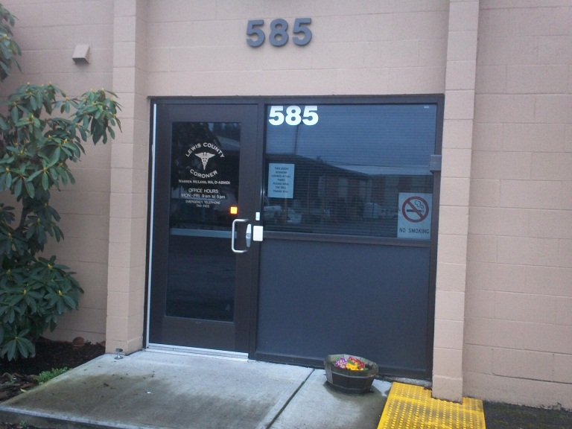
585 NW Center St. Chehalis, WA, 98532 360-740-1376 | 2012 ANNUAL REPORT
It is important to remember that every statistic in this report represents a person who is missed by family and friends and is also a loss to our community.
Warren McLeod, MA, D-ABMDI Coroner

TABLE OF CONTENTS

Mission and Vision Statements.................................................................................................2

Forward……………………….............................................................................................................3

Description and purpose............................................................................................................4-7

Accomplishments in 2012……………………………………………………………………………………………………..8-9

Annual death statistics……………………………………………………………………………………………………….….10

Volunteer programs/hours……………………………………………………………………………………………………..11

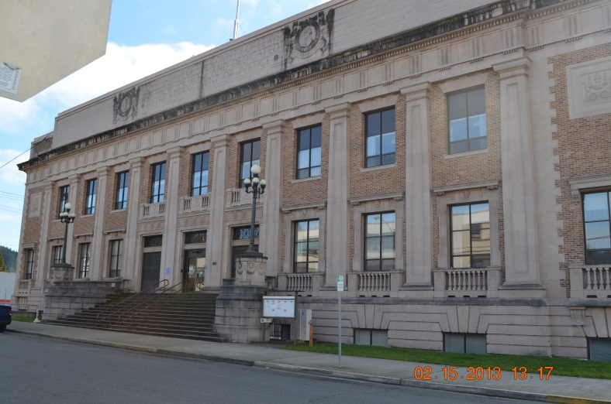

MISSION STATEMENT
The Lewis County Coroner’s Office determines the cause and manner of reported deaths by conducting professional medicolegal death investigations while ensuring that everyone who has suffered a loss is treated with dignity, respect and compassion. The Lewis County Coroner’s Office is dedicated to improving the professional development of all staff through continued training while working collaboratively with the community to identify and proactively respond to issues and concerns related to death investigations.

VISION STATEMENT
1. The LCCO is accessible and accountable to the public, media and other elected officials. 2. The LCCO continually strives to increase the proficiency and professionalism of all staff members through training. 3. The LCCO endeavors to develop and strengthen partnerships with the public safety community. 4. The LCCO works with community partners to adopt a proactive approach to reducing preventable deaths.

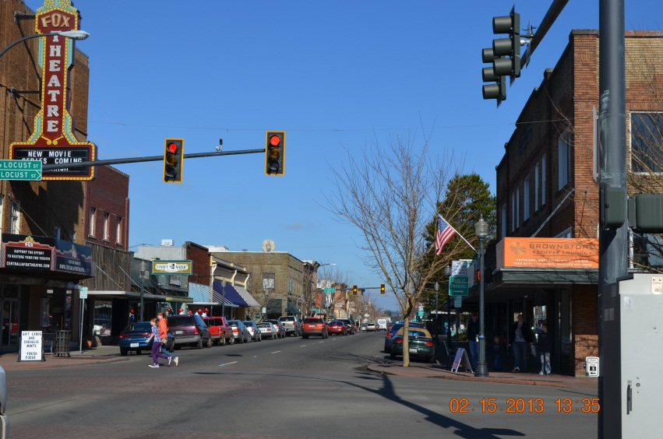
FORWARD
The Lewis County Coroner’s Office (LCCO) serves the county by investigating sudden, unexpected, violent, suspicious and unnatural deaths. All members of the LCCO staff recognize that every death investigated involves grieving family members as well as friends and co-workers. Conducting timely and complete death investigations is necessary, in part, to assist those grieving people. Complete investigations also help families with the settling of issues such as estate and insurance claims as well as any criminal or civil actions. Often times questions come up long after the death that were not thought of at the time and complete and thorough investigations aid in the answering of these questions.
Deaths investigated by the LCCO include on-the-job deaths and these investigations are conducted in conjunction with the Washington State Department of Labor and Industries (L & I).
The LCCO also plays a role in the area of public health by isolating and identifying the causes of sudden, unexpected deaths that might affect groups of people. If an infectious agent or toxin is implicated in a death the LCCO works with Lewis County Public Health to ensure family members and other contacts of the decedent receive any needed medical treatment.
In cases that are unexpected deaths at home, suspicious circumstances, homicide, suicide, drug-related or traffic deaths the LCCO works closely with the jurisdictional law enforcement agency. The agencies conduct parallel investigations while cooperating fully with each other. All members of the LCCO staff are subject to being subpoenaed to testify in civil/criminal cases as to the extent of the investigation they conducted.
In summary the LCCO provides expert medicolegal death investigations and services related to deaths that are of concern to the health, safety and welfare of Lewis County.
Lewis County is approximately 2, 402. 80 square miles and has a population of approximately 75, 901.

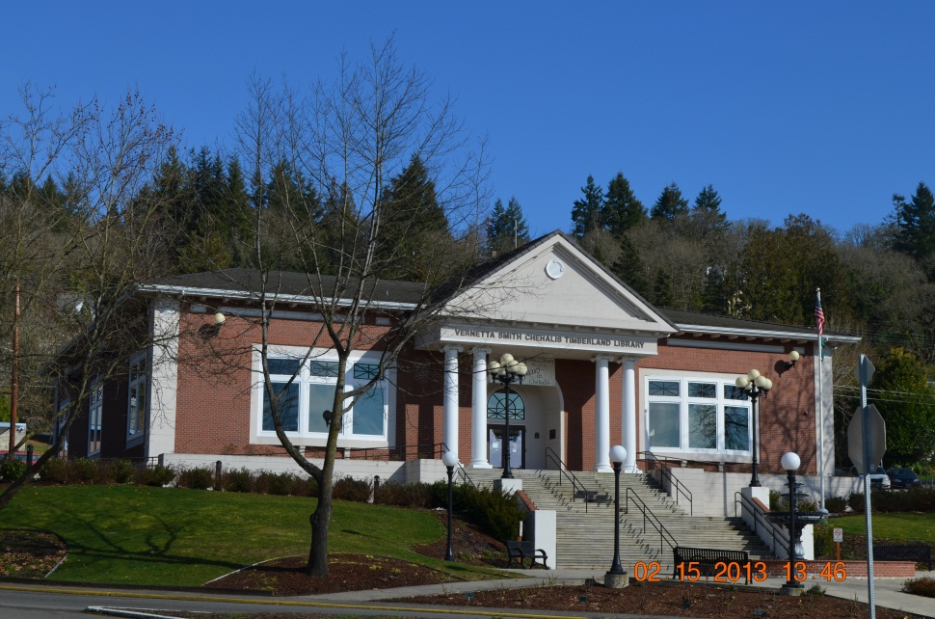

DESCRIPTION AND PURPOSE
The LCCO is funded by Lewis County and operates under the direction of the Coroner. The Coroner is a half-time elected position and is responsible for the administration of the office, the budget, accounts payable, the staff and for determining the cause and manner of deaths reported. The Coroner also responds to calls in the field.
The Chief Deputy Coroner is a full-time position and serves at the will of the Coroner. The Chief Deputy Coroner is responsible for payroll, staffing and is often times the first line of contact with families. . The Chief Deputy Coroner also responds to calls in the field.
The staff is comprised of Deputy Coroners who are classified as “extra help” by the county. The Deputy Coroners work on-call from home and respond to the locations where deaths have occurred in order to conduct medicolegal death investigations. These investigations involve:
- obtaining preliminary information from law enforcement
- getting detailed information from families and witnesses
- locating and documenting physical evidence
- documenting the scene and decedent with photographs
- performing a comprehensive external physical examination of the decedent
- inventorying the prescription medications
- inventorying the property
- arranging for transport of the decedent
- getting the decedent identified
- locating and notifying the next of kin
- obtaining medical records
- writing a comprehensive investigative report
- drawing toxicological specimens
- assisting during autopsies
- testifying in court as needed

Deaths that fall under the jurisdiction of the Lewis County Coroner’s Office are defined by state statute (RCW 68.50.010) and include but are not limited to:
- deaths of persons who were in apparent good health without medical attendance within the thirty-six hours preceding death
- deaths caused by unnatural or unlawful means
- death occurs under suspicious circumstances
- where a coroner's autopsy or coroner's inquest is to be held
- death results from unknown or obscure causes
- death occurs within one year following an accident
- death is caused by any violence whatsoever
- death results from a known or suspected abortion; whether self-induced or otherwise
- death results from drowning, hanging, burns, electrocution, gunshot wounds, stabs or cuts, lightning, starvation, radiation, exposure, alcoholism, narcotics or other addictions, tetanus, strangulations, suffocation or smothering
- death is due to premature birth or still birth
- death is due to a violent contagious disease or suspected contagious disease which may be a public health hazard;
- death results from alleged rape, carnal knowledge or sodomy
- death occurs in a jail or prison
- when a decedent is found dead or is not claimed by relatives or friends
Not all cases reported to the LCCO fall within our jurisdiction. There are decedents who are on hospice and their death is expected due to a terminal illness.
The LCCO also has a pre-registration program whereby a physician can place their patient on a list indicating the patient is suffering from a diagnosed medical condition, the family’s mortuary preference and attesting that the physician will sign the Death Certificate. When the decedent passes away the family calls the mortuary directly and the decedent goes to the mortuary. This allows people to die at home with dignity and peace of mind for the families.
The Coroner is responsible for determining the cause and manner of all reported deaths. A cause of death is what directly led to the person’s death. The causes of death are numerous and can include:
-heart attack -stroke -gunshot wound -drowning -cancer -overdose -pneumonia
The manner of death is a category that the cause of death falls under and there are only five manners:
Natural: Deaths from the natural disease process.
Homicide: The killing of one human being by another.
Suicide: The intentional taking of one owns life or a death that results from engaging in a behavior that a reasonable person would know could result in death.
Accidental: There is no intent on the part of the decedent to end their life.
Undetermined: When the manner of death is not able to be forensically ascertained.
Cases that do fall under the jurisdiction of the LCCO will have a scene investigation completed and the decedent can be released to the mortuary of the family’s choice or will be transported to LCCO if the family has no mortuary choice at the time of death in cases of natural deaths.
There are times the decedent has to be transported to the LCCO because their death requires an examination by a Forensic Pathologist. The LCCO has a contract with two (2) Board Certified Forensic Pathologists who come to the facility to perform these exams as needed. The exams can either be:
1. External exam: A comprehensive head-to-toe external exam where the pathologist is looking for signs of specific types of diseases or injuries.
2. Autopsy: A comprehensive head-to-toe external examination as well as a complete internal examination. Contrary to popular belief decedents who have an autopsy performed can still be viewed by family and friends afterwards at the funeral home.
Not every death that occurs or comes into the office is autopsied. The only cases that are automatically autopsied are homicides, violent deaths, suicides, traffic collisions. Many times the decedent will be brought to the LCCO for a physical examination. The only times this office is allowed to perform an autopsy is outlined by state statute and covers the types of deaths listed above. In cases of natural deaths we have no jurisdiction to perform an autopsy since it was not a violent or unexpected death.
The LCCO is also involved in toxicological testing. This involves drawing various biological samples for testing to see what level of any substance might be in the decedent’s system. This testing is done by the Washington State Patrol Crime Laboratory at no charge to the county. What is frustrating in these cases is that unlike television, the toxicological results take anywhere between six (6) to eight (8) weeks to come back. This turnaround time is pretty much the standard time nationwide.
The LCCO has other responsibilities as well:
1. Ensure that all decedents are positively identified and this is done by:
a. Viewing the decedent
b. Viewing driver license photos or post mortem photos
c. Fingerprints
d. Dental exams
e. DNA. Again unlike television, this does not have a quick turnaround. We rely on the University of North Texas to perform the DNA exams at no charge and these can take well over one year, sometimes longer, to complete.
2. Locate and notify the next of kin for the decedent. Per the RCW the progression for next of kin is as follows:
The designated agent of the decedent as directed through a written document signed and dated by the decedent in the presence of a witness. The direction of the designated agent is sufficient to direct the type, place, and method of disposition;
The surviving spouse or state registered domestic partner;
The majority of the surviving adult children of the decedent;
The surviving parents of the decedent;
The majority of the surviving siblings of the decedent;
A court-appointed guardian for the person at the time of the person's death.
Locating and notifying the next of kin is often times very easy to do as family members are present or nearby when a person passes away. There are other cases where the family is not so easy to find. We use a variety of search engines available to law enforcement to try and locate families. In cases where families cannot be located within ninety (90) days the decedent is cremated at the county expense and the cremated remains are held at the LCCO until family members might be found.

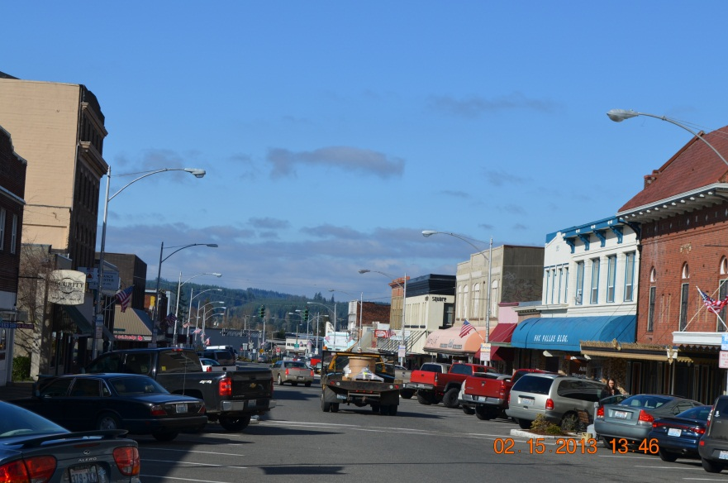

Accomplishments in 2012
1. In April 2012 the LCCO became one of only three coroner’s offices in the State of Washington to receive accreditation through the International Association of Coroner’s and Medical Examiners (IAC&ME). This process involved opening the facility and the policy and procedures to close scrutiny by an auditing team. The facility was checked to be sure it met the standards set forth for facilities and forensics. The policies and procures were examined to be sure they complied with the established standards for the IAC&ME. Both the facility and policy audit were met with success and accreditation was awarded. This means that the way the facility is set up and the office procedures for conducting investigations, handling decedent’s and families and performing forensic procedures is strictly in line with the standards set in place internationally for coroner’s offices. The awarding of this accreditation was the culmination of a lot of hard work and was the end result of ten months of work by everyone associated with this office.
2. The LCCO has four staff members who are nationally registered death investigators through the American Board of Medicolegal Death Investigators (ABMDI). Three other staff members are in the process of obtaining that registration. In order to be eligible a person has to be employed by a coroner or medical examiner system. They are required to have 640 hours of death investigation experience and then have to pass a 300 task hands on skill test as well as a four hour written examination. Having nationally registered death investigators means having staff that are trained to the national standards of death investigation and in order to have their registration renewed they must obtain a set number of training hours during the five certification period.
These two accomplishments mean that Lewis County has a coroner facility and staff that are operating at the professional standards established by international and national agencies. In short the office and staff are both something the citizens of this county can be proud of.
3. The unclaimed cremated remains of 14 people were laid to rest in Claquato Cemetery. The remains had been in the office dating back to the mid-1990’s. No family could ever be found for these folks and a collaborative effort was made with Claquato to provide a final resting place for the remains. The agreement allows for the families to disinter their loved ones if they come forward in the future and also for us to be able to intern any future unclaimed cremains.
4. In 2012 approximately $3, 000 in grant money was obtained for equipment that did not come from the operating budget for the office and this was used to purchase a laptop.
5. The LCCO continued its commitment to community service by becoming a permanent member of the Lewis County Stop DUI Task Force and the Lewis County Vulnerable Adult Task Force.
6. The LCCO provided presentations to various county fire districts on what the role of the coroner staff is at scenes and how the agencies can work closer together to benefit the citizens of the county.
7. The LCCO staff participated in a mock disaster drill that took place at Adna HS using volunteers as multiple victims. The mass fatality trailer was utilized and all of the equipment purchased using previous grants was put into use. The drill enhanced the readiness and ability of the staff to respond in the event of an actual mass fatality.
8. The LCCO began participating in the Electronic Death Reporting System (EDRS) whereby the creation and processing of death certificates is all done electronically. This eliminates the need for mortuary staff to drive to several locations to have the documents signed, numbered and filed. This has dramatically decreased the time involved in families being able to get the death certificates for their loved ones.

STATISTICS
The statistics for 2012 are generic and will not list details in the types of cases. This is done purposefully to preserve the dignity and confidentiality for the surviving family members and friends.
Total number of deaths in Lewis County in 2012: 822 (53 deaths more than in 2011)
NATURAL | HOMICIDE | SUICIDE | ACCIDENTAL | UNDETERMINED | OUT OF COUNTY ASSISTS | AUTOPSIES
783 | 4 | 14 | 19 | 2 | 0 | 65

2011 Statistics
NATURAL | HOMICIDE | SUICIDE | ACCIDENTAL | UNDETERMINED | OUT OF COUNTY ASSISTS | AUTOPSIES
769 | 4 | 9 | 29 | 3 | 2 | 40

VOLUNTEER HOURS
The LCCO has a Reserve Deputy Coroner program in place and this is a volunteer, non-paid position. To be a Reserve Deputy Coroner a person fills out an application, has an interview and then must undergo a background check. Once sworn in as a reserve they attend the in-house Reserve Training Program. They then have 40 hours of mandatory service working in the office performing data entry, assisting during autopsies and assisting staff. Once the 40 hours of office time is completed the reserves are then eligible to go out into the field on calls with Deputy Coroners. Reserves are also required to attend the monthly training meetings held at LCCO. Topics covered at the training include medicolegal death investigation, crime scene protocols, working with law enforcement, various types of deaths as well as many other related topics. When we are looking to hire Deputy Coroners we look to our pool of reserves first.
The LCCO also collaborates with accredited colleges and universities to accept interns through criminal justice and forensic programs. This allows students to gain hands on experience while earning credit in their area of study.
The total number of volunteer hours recorded through our office by Reserve Deputy Coroners and interns was 1030.75 hours. This in no small part assisted the office in operating more efficiently without bringing any cost to the county.

2011 estimate. http://quickfacts.census.gov/qfd/states/53/53041.html

