Instructions for accessing the Aetna medicine search tool:
- Start by clicking on the link: https://www.aetna.com/individuals-families/find-a-medication.html.
- Input the following information in the boxes:
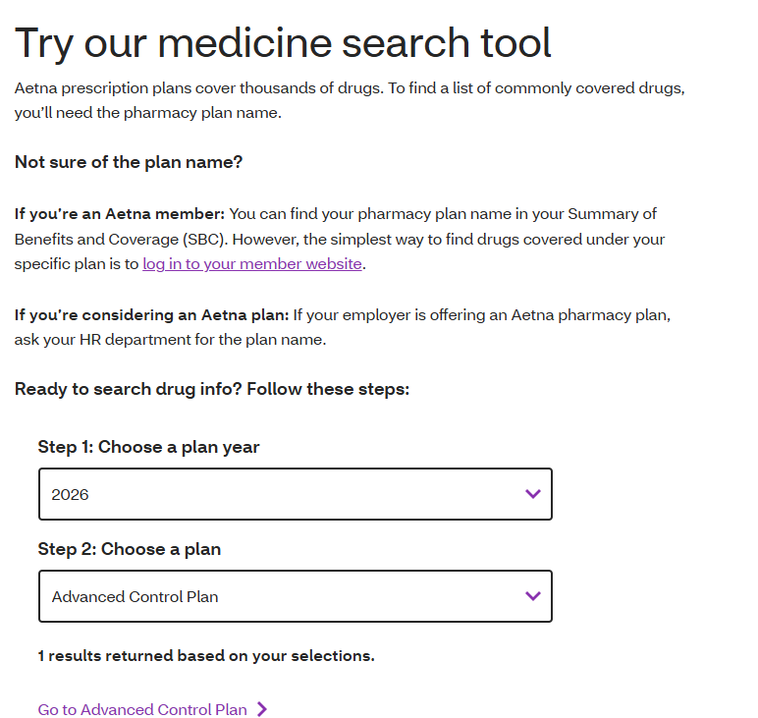

- The corresponding page will open, and you will want to click on Find Medicine: 