2025 SHOP WITH A COP
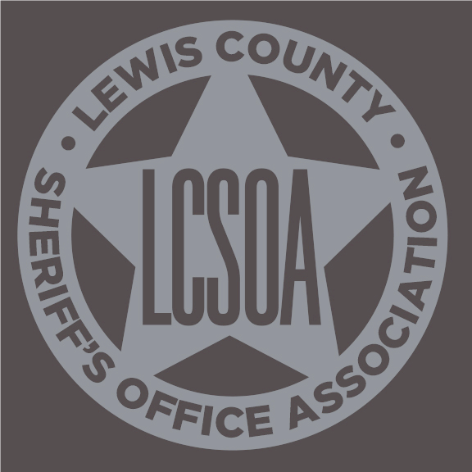

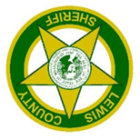
SPONSORED BY THE LEWIS COUNTY
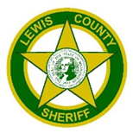
SHERIFF’S OFFICE ASSOCIATION
DECEMBER 10, 2025

The Lewis County Sheriff’s Office, for the 24th consecutive year, is partnering with United Way of Lewis County, in coordinating “Shop with a Cop”. This is an opportunity for children from disadvantaged circumstances to go Christmas shopping for their immediate family. Children are paired up with deputies and shop with money raised by the Lewis County Sheriff’s Office Association, community donations, and a grant received by Walmart.

What we are asking from you is to help us find the children who would benefit from such an experience. If a child has had negative experiences with law enforcement in the past, this is an opportunity to have some contact with officers in a positive light. It allows the deputies to interact with children in an uplifting atmosphere.

On December 10th, the selected children will meet at Walmart, pair up with their “cop” and the shopping begins. The child comes with a list of the family members and their ages so appropriate items can be selected. At the conclusion of the shopping, the child rides to the Lewis County Law & Justice Center in a Sheriff’s Office vehicle. With additional help from support staff and volunteers, the gifts will be wrapped, games are played, and pizza is brought in for dinner. The atmosphere is kept festive and it is a fun-filled evening for all involved.

Criteria
- Child must be in second grade (7 years old) thru high school
- Child resides in Lewis County
- One child per family
- Child has not participated in the past
- Child must be able to separate from family while shopping

Application Considerations
- Children from families who may have negative feelings or mistrust of law enforcement
- Children from families with severe financial need

Schedule Timeline
- Application deadline is November 20th
- Family notification begins November 25th
- “Shop with a Cop” on Wednesday, December 10th, starting at 4:45 p.m.

A committee will make selections from the applications based on the number of deputies signed up to participate. To ensure confidentiality where needed, we will contact the person that filled out the application and make the arrangements to notify the family of the child. You may send in an application for more than one child, keeping in mind that only one child per family will be selected.

Applications are available to complete online at https://lewiscountywa.gov/offices/sheriff/
Submit completed application online to Sheriff@lewiscountywa.gov
or print and mail to the following:

LEWIS COUNTY SHERIFF’S OFFICE ASSOCIATION
SHOP WITH A COP PROGRAM
345 W. MAIN STREET
CHEHALIS, WA 98532

Applications may also be faxed to 360-740-1476. If there are any further questions, you may call the Lewis County Sheriff’s Office at 360-748-9286. The application deadline is November 20th.

INCOMPLETE OR ILLEGIBLE APPLICATIONS WILL NOT BE CONSIDERED.

