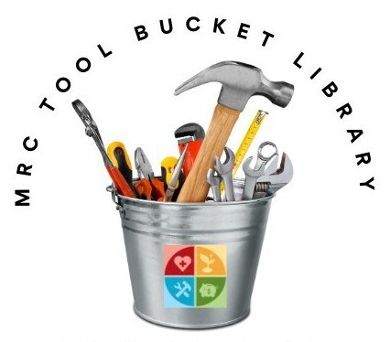
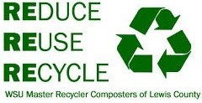
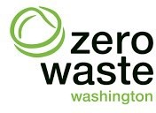
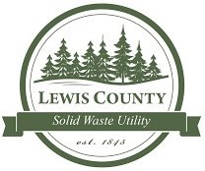
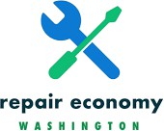
WSU LEWIS COUNTY EXTENSION
Master Recycler Composters
Other MRC Projects
- Repair and Sustainability Fairs held
twice a year at Centralia College and annually at Centralia College East (Morton).
- Gadget Library at Chehalis Timberland
Library.
How can you help?
VOLUNTEER:
Community volunteers needed for the following positions:
- TOOL LIBRARIAN
- TOOL CATALOGER / INVENTORY
- TOOL FIXER / MAINTENANCE
Volunteer Fixers are also needed at Repair & Sustainability Fairs.
EDUCATION: Opportunities to teach a variety of home repairs, sewing, gardening, and food preservation skills.
DONATION: Tool donations are gladly accepted (except for gas powered tools) and are tax-deductible.
MRC Tool Bucket
Library
Like us on our Facebook page!
Have more questions?
Call us at (360) 520-3206 or email mrctoolbucketlibrary@gmail.com
We are located at the
Floral Park Sustainability Project
103 East Floral St.
Centralia, WA 98531
(Next to the Central Transfer Station)

Open every Friday 10 am—1 pm
Saturday 9 am— 1 pm
WSU Lewis County Master Recycler Composters
17 SW Cascade Ave.
351 NW North St. (mailing)
Chehalis, WA 98532
(360) 740-1216
jason.adams@lewiscountywa.gov

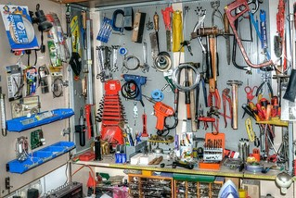
What is a Tool Library?
It is just like a regular library, but with tools instead of books! The MRC Tool Bucket Library provides free or low-cost access to shared tools and other durable goods and encourages self-reliance, re-use, repair, and reduced consumption.
In the future, we will offer a Maker-Space which will provide space for learning how to use household tools and enable members to use large tools that are not portable and require advance knowledge to operate or supervision.
$0-$30,000 | $0
$30,000-$50,000 | $30
$50,000-$75,000 | $50
$75,000 + | $50 +

How much will it cost to
borrow tools?
Borrowing fees help us maintain and repair the tools we share and range from $0-10 per tool.
All tools must be returned clean and in
good working condition.

Where does the money from membership, borrowing and late fees go?
Our aim is to keep the MRC Tool Bucket Library a financially sustaining 501(c)3, non-profit organization.
We use membership donations and late fees collected to run this volunteer project by buying and maintaining our tools for the community to share.
This material is funded through a Public Participation Grant from the Washington State Department of Ecology.
How do I become a member?
- Complete the Membership
Application.
- Sign and Date the Liability Waiver and Tool Use Policy.
- Consider making a donation or volunteering.
*Two pieces of local identification are needed to verify that you are 18 years of age.
Suggested Donation Sliding Scale
The amount is based on self-identified
household income levels. Membership contributions are recommended but not required. No one will be turned away, and we never track or record household
income levels.
Annual Income Donation
Este material ha sido financiado por una Subvención de Participación Pública del Departamento de Ecología del Estado de Washington.

WSU Extension programs and employment are available to all without discrimination. Evidence of noncompliance may be reported through your local WSU Extension office.

