Lewis County  Youth Mentorship Program  April 2024 | 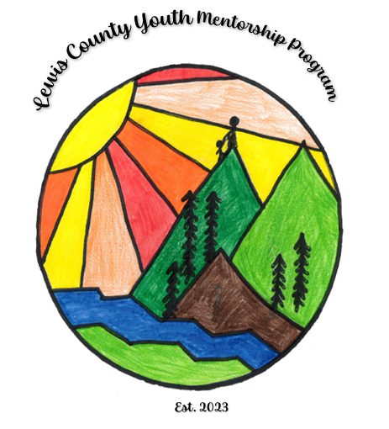  The new Lewis County Youth Mentorship Program Logo was drawn by: Carmen Tavarez of Centralia, WA as voted on by Lewis County employees. Carmen’s drawing was voted on and chosen from among over 60 entries by Lewis County youth, Congratulations Carmen.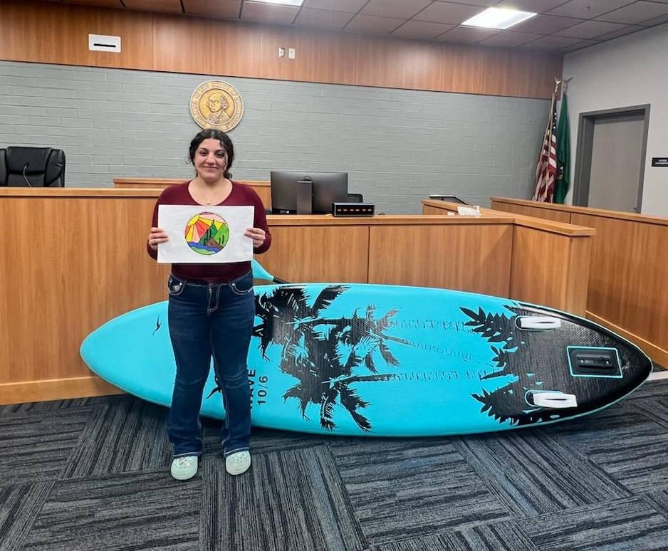
Inside

This
Issue
PG. 1
Welcome to Lewis County Youth Mentorship Program
PG. 2
Upcoming Events and Trainings
PG. 5
Community and News
"A mentor is someone who sees more talent and ability within you, than you see in yourself, and helps bring it out of you." — Bob Proctor | Lewis County Youth mentorship  Mission Statement  Our mission is to inspire youth through meaningful relationships to make positive choices that will build resiliency, encourage growth, and enable them to pursue a successful future.  Vision Statement  Our vision is a Lewis County where every youth is supported, encouraged and empowered to reach their full potential through purposeful connections with caring adults.

Upcoming Events and Trainings

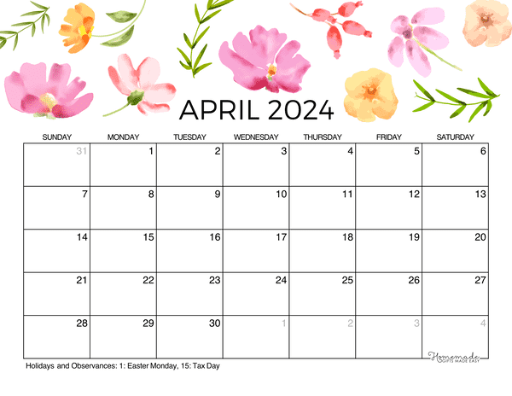

Upcoming events in Lewis COunty

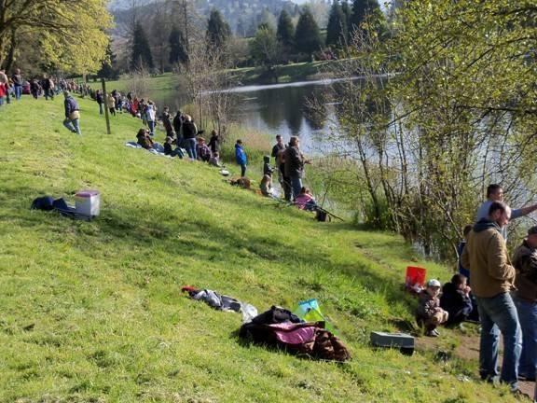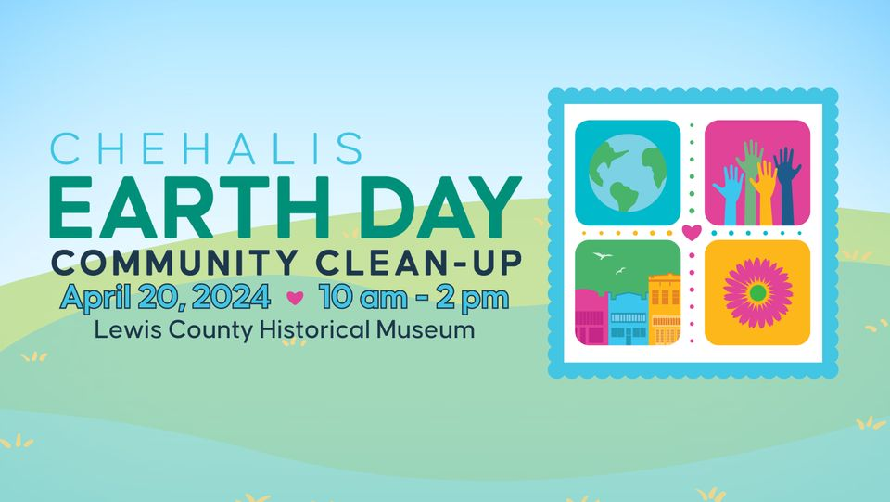

Lions Fishing Derby Fort Borst Park Historic downtown centralia
April
^{5th Fri and 6th Sat}
3rd Annual Spring Fling at The Loft @ The Loft
Apr 5 @ 12:00 pm – 4:00 pm

Meet Fossil Team PDX @ Hands On Children's Museum in Olympia

Apr 5 @ 10:30 am – 4:00 pm

Nevermind (Nirvana Tribute) and Jar of Flies (Alice in Chains Tribute)
McFiler’s, Chehalis Theater @ 8:00pm

APRIL
6th Sat
Up-Potting for Healthier Plants with Lewis County Master Gardeners @ Greenhouse at Fort Borst Demo Gardens @ 10:00 am

Lewis County Model Railroad Club Show and Swap Meet is coming up on April 6-7. SW WA Fairgrounds, 2555 N. National Ave, Chehalis, WA

APRIL
12th Fri and 13th Sat

Annual Home and Garden Show, SW Washington Fairgrounds
APRIL
14th Sun
Hope For Tomorrow Dessert Fundraier
APRIL
20th Sat
Free Entrance Day at Mount Rainier National Park
Fee-free days at national parks offer an incredible opportunity for nature enthusiasts and adventure seekers to explore the natural wonders of the United States without any admission fees.

In celebration of Earth Day, Experience Chehalis is organizing an Earth Day Community Clean-up on Saturday, April 20 from 10 am – 2 pm. The public is invited to come downtown and join in the activities. Volunteers can check in at the Lewis County Historical Museum and choose from a list of activities including weeding and wiping off benches to sweeping downtown and collecting litter in areas throughout Chehalis. To make it a little more fun, Experience Chehalis will offer raffle tickets in exchange for bags of litter returned. Stop by for a trash bag at the Lewis County Historical Museum, and for each bag of litter picked up in Chehalis, volunteers will receive a raffle ticket towards downtown gift certificates and Earth Day-themed art by local artists. The drawing will take place at 2 pm and entrants need not be present to win. Experience Chehalis asks volunteers to call 360-345-1738 to register. Those who register by April 10th will receive a free Experience Chehalis Earth Day t-shirt. On the day of the event, please visit the museum to check-in. Participate for an hour or the whole event. For high school students, this can be a great opportunity to gain a few more volunteer hours.

APRIL
21st Fri
High Tunnel Gardening: Community Learning with Farmer Burke, High tunnels are incredibly useful in our climate for extending your growing season. They require some special attention as well. Learn what you need to grow in your own high tunnel! Held at Olequa Farm: 1785 Ferrier Road, Winlock Classes are $10 and nobody is turned away for lack of funds. Family and kid pricing available. Please reach out if you need a scholarship.

APRIL
27th Sat
Join us for a weekend of engaging Revolutionary War era military demonstrations, fife and drum music, and 18th century living history camp on the grounds of the Veterans Memorial Museum in Chehalis, WA. Entertaining and educational activities for the whole family!
Learn how an 18th century cannon is fired- then see it happen!
Watch the infantry regiments drill and fire their muskets!
Study 18th century replica maps with the HMS Chatham.
Talk with Patriot and Loyalist civilians in camp.
Listen to battle-ready songs of the Columbia Fife & Drum.
See how life was lived in the Revolutionary War Era.
Donations are appreciated. Free parking and restrooms are available. Handicap accessible grounds. Homeschool groups welcome. Families and children encouraged. Veterans Memorial Museum, Chehalis WA

Upcoming trainings

Stewards of Children®
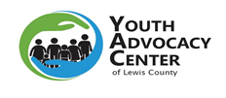The Youth Advocacy Center of Lewis County (YAC) is a partner in prevention organization with Darkness to Light, a leader in child sexual abuse prevention education, research, and advocacy. The Youth Advocacy Center of Lewis County, Twin City Rotary Club, and United Way of Lewis County are hosting Stewards of Children® trainings. The trainings are FREE prevention trainings provided by the Youth Advocacy Center of Lewis County that teaches adults how to prevent, recognize, and react responsibly to child sexual abuse. The program is designed for organizations that serve youth and for individuals concerned about the safety of children. It is the only nationally distributed, evidence-informed program proven to increase knowledge, improve attitudes, and change child protective behaviors. To learn more about or to register for the Stewards of Children® trainings provided by the Youth Advocacy Center of Lewis County,
MAY 10, 2023

Resources
Lewis County Food Bank Coalition
750 SW 21st St
Chehalis, WA
(360) 330-1519

Lewis County Gospel Mission Food Pantry - Food Distribution Center
72 SW Chehalis Ave
Chehalis, WA
(360) 996-4474

Greater Chehalis Food Bank
750 SW 21st St
Chehalis, WA
(360) 748-1226

Gods Portion Food Bank
1025 F. St
Centralia, WA

Hub City Mission Food Pantry - Food Distribution Center
416 N Tower Ave
Centralia, WA
(360) 748-0119

Salvation Army-Centralia - Food Distribution Center
303 N. Gold
Centralia, WA
(360) 736-4339

Gather Church Food Bank and Meal Program - Food Distribution Center
408 W. main St
Centralia, WA
(360) 827-0264

Winlock-Vader Food Bank
503 NE 1st St
Winlock, WA
(360) 785-2185

Somma Food Bank
144 Wilcox Rd
Salkum, WA
(360) 985-7211

Toledo Food Bank - Food Distribution Center
130 2nd St N., Toledo, WA
(360) 978-4305

Winlock Vader Food Bank
203 NE 1st St
Winlock, WA
(360)785-6399

Helping one person might not change the world. But it could change the world for one person. |  | Community AND nEWS  Chehalis-Centralia Railroad to resume weekend excursions beginning April 6  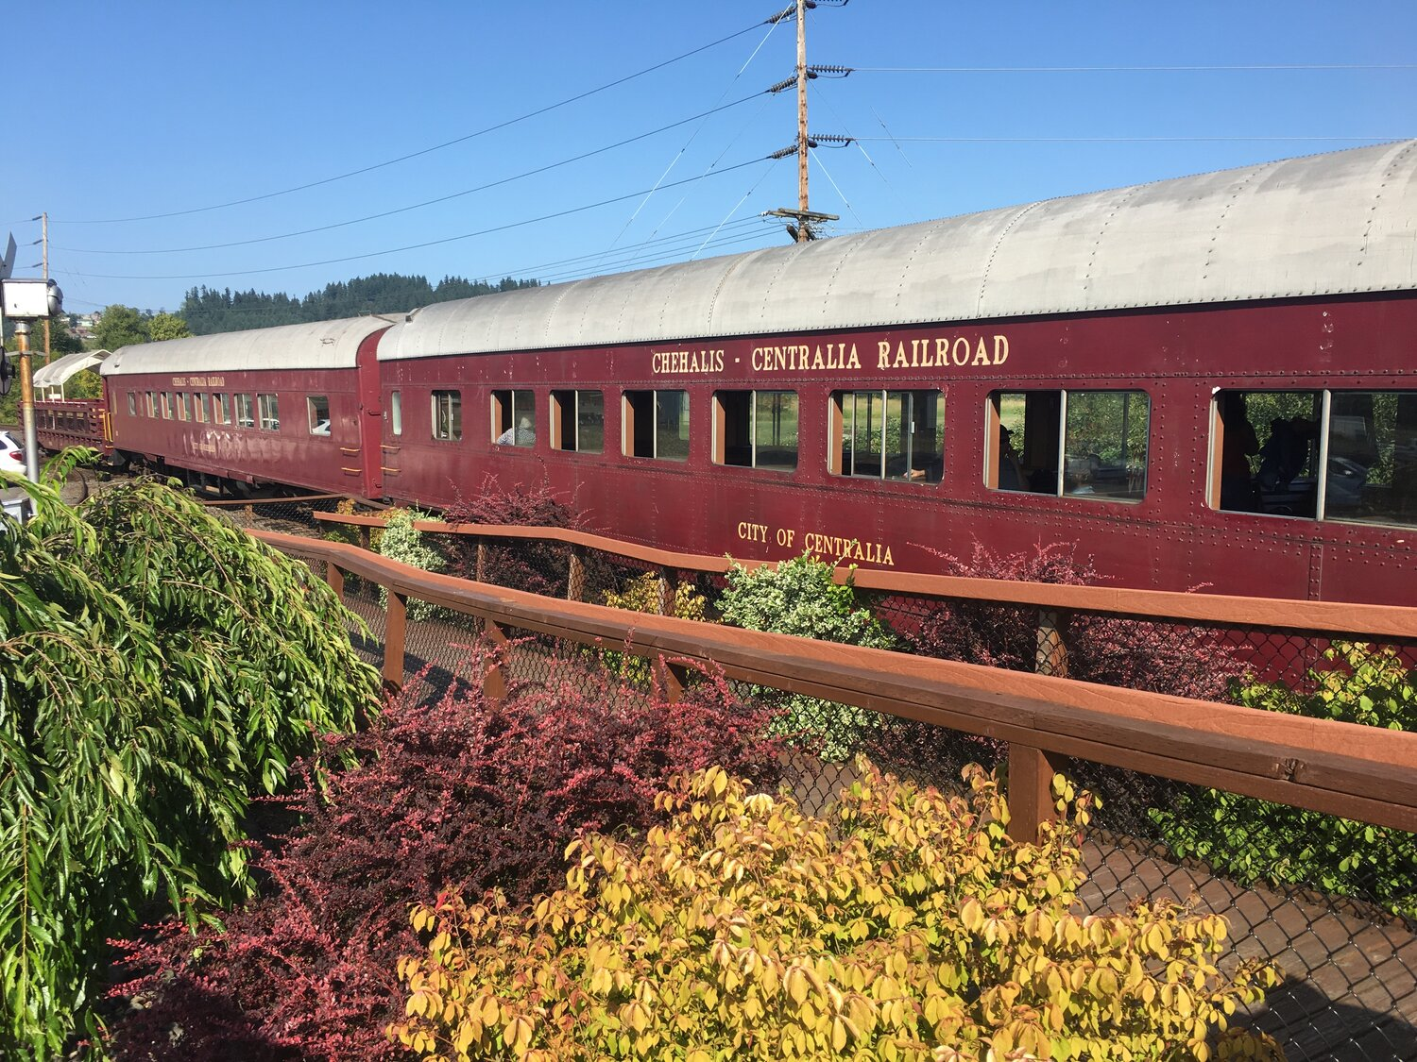  Mineral Lake’s 31st annual fishing derby scheduled for end of April, tickets on sale on April 26  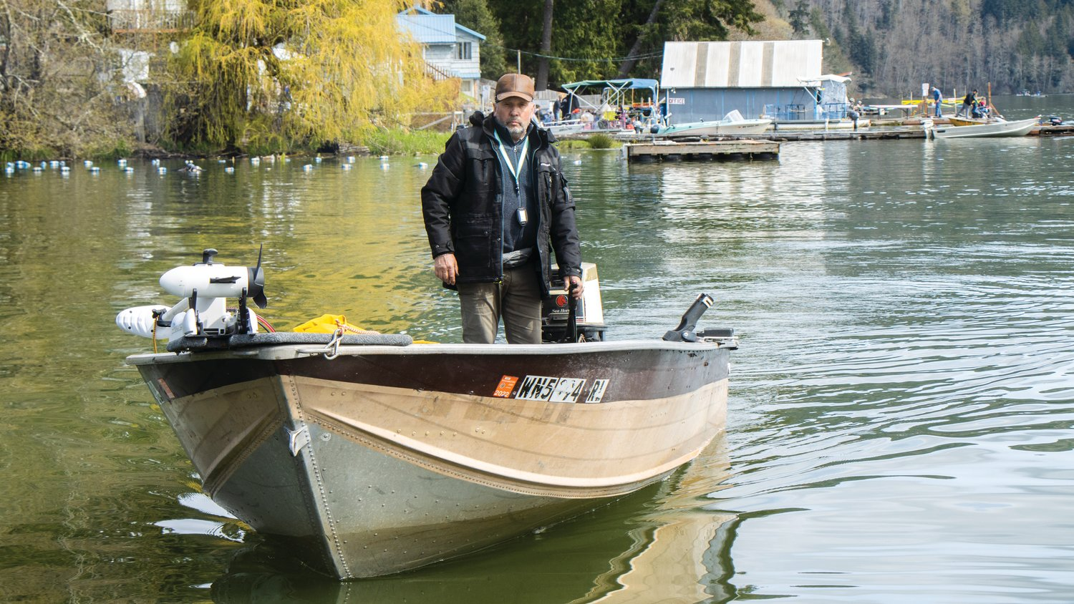  Mossyrock Grange offering area residents free tax return filing help this weekend and in April  